Employee Value Proposition for public sector employers

Research report

2025

Authorised and published by the Victorian Independent Remuneration Tribunal

Ground Floor, 1 Treasury Place

Melbourne VIC 3002

**ISBN** 978-1-923295-07-0 (**pdf/online/MS word**)

© State of Victoria.



You are welcome to re-use this work under a Creative Commons Attribution 4.0 licence, provided you credit the State of Victoria (Victorian Independent Remuneration Tribunal) as author, indicate if changes were made and comply with the other licence terms. The licence does not apply to any branding, including government logos.

Except where otherwise indicated, the images in this publication show models and illustrative settings only, and do not necessarily depict actual services, facilities or recipients of services.



Contents

P29#yIS1

Executive summary 8

1 Introduction 11

Public sector EVP is relevant to the Tribunal’s work 11

The Tribunal undertook a project to further its understanding of public sector EVP 12

Several stakeholders provided invaluable support 13

2 What is Employee Value Proposition 14

There have been attempts to categorise individual components of EVP 15

The needs of employees affect a position’s EVP 17

Employees weigh up the value provided by EVP components when choosing between offers 20

Monetary pay is a critical component of EVP 22

An emerging benefit is the right to work outside the office 23

Employees are attracted to jobs that they find meaningful 24

Employees factor in an organisation’s culture 25

3 Previous research on the EVP in the public sector 27

Public sector roles and the benefits they provide have changed over time 27

[A preference for public sector work is referred to as Public Service   
Motivation 29](#_Toc206573932)

Perception and expectations of public sector roles 32

4 EVP in the Victorian public sector 35

[The Victorian public sector includes public service bodies and   
public entities 35](#_Toc206573935)

Legislation and policies define which staff are executives and govern their employment 36

The Tribunal’s consultations shed light on the EVP of Victorian public sector executive roles 40

Public sector organisations develop and advertise their EVP to help attract and retain staff 44

Previous research examined why staff chose to take senior VPS roles 46

5 Objectives and design of the Tribunal’s survey 48

The survey was designed to gather data and job preferences from the target audience 49

[The Tribunal worked with several organisations to distribute the   
survey link 52](#_Toc206573942)

Analysis of choice-based conjoint results requires the use of several statistical techniques 52

6 Results of the survey 56

Responses were collected from a wide range of individuals 56

Remuneration and workload were the attributes with the greatest relative importance 57

While pay increases provide diminishing marginal utility, current salary has a large impact 59

Respondents had a clear preference for public service jobs 61

Preference for public service work was positively related to public service motivation 62

The survey examined preferences for several career development opportunities 67

Gender and the type of work people do influence their preferences 67

Respondents discussed other matters they look for when choosing a job 69

7 Key findings 71

There is a strong public sector EVP 71

The findings support how the executive remuneration bands have been positioned 72

Employers can use the project’s findings to optimise and tailor employment offers 74

References 79

Appendix A — survey questions 87

Appendix B — summary of survey data about respondents 94

Appendix C — part-worths from choice-based conjoint exercise 101

List of figures, tables and boxes

Box 2.1: Example definitions of EVP used in academic literature 15

Table 2.1: Results of PWC’s What Workers Want survey – relative ranking of EVP levers 15

Table 2.2: Gartner Global Talent Monitor survey, top 10 Drivers of Employee Attraction and Attrition, Australia, 1Q25 16

Table 2.3: ERG Theory needs categories and related EVP components 18

Box 2.2: Regional differences in EVP preferences 19

Table 2.4: Grouping of survey respondents based on valued job attributes 21

[Table 4.1: Summary of mandatory employment conditions set by the   
PEER Policy 37](#_Toc206169999)

Box 4.1: References to size, available career pathways and access to learning and development opportunities in EVP statements of other Australian jurisdictions 42

Table 4.2: Timeline of key changes in public sector executive employment in Victoria 44

Box 4.2: EVP case studies from the Victorian public sector 45

Box 5.1: Uses and benefits of choice-based conjoint analysis 50

Table 5.1: Attributes and levels used for CBC model 51

Box 5.2: How utility of levels can be approximated in dollar terms 54

Box 5.3: Multinomial logit model formula for calculating share of preference if two options are compared 54

Box 5.4: Relative importance and how it is calculated 55

Table 6.1: Relative importance of attributes, all and public and private sector 57

[Table 6.2: Relative importance of attributes, comparison of VPS and   
PE employees 58](#_Toc206170009)

Figure 6.1: Relative importance of the remuneration and workload attributes, depending on respondent’s current salary 59

Figure 6.2: Part-worth of remuneration levels, depending on respondent’s current salary 60

Figure 6.3: Part-worths of sectors, depending on sector of current work 61

Box 6.1: Methodology used to calculate PSM score and group for respondents 62

Figure 6.4: Part-worths of sectors, depending on PSM group 63

Figure 6.5: Share of preference, flexible work options 64

Figure 6.6: Part-worths of contract length levels, depending on sector of current work 65

Figure 6.7: Part-worths of contract length levels, depending on current salary 66

Figure 6.8: Share of preference, career development opportunities 67

Box 6.2: Differences in the survey results between men and women 68

Box 6.3: Case study — job preferences of those who do engineering work day-to-day 69

[Figure 6.9: Word cloud of answers to ‘Is there anything else you would like to tell us about what you would look for when choosing a new senior management   
job?’ 70](#_Toc206170023)

Table 7.1: Australian General Market data, April 2024 73

Abbreviations and glossary

|  |  |
| --- | --- |
| Term or abbreviation | Definition |
| ABS | Australian Bureau of Statistics |
| AGM | Australian General Market |
| ANOVA | Analysis of variance — a type of statistical test used to assess the difference between the means of more than two groups. |
| APS | Australian Public Service |
| BIU | Behavioural Insights Unit, a former unit of the Department of Premier and Cabinet |
| CBC | choice-based conjoint |
| CEDA | Committee for Economic Development of Australia |
| CEO | Chief Executive Officer |
| EVP | Employee Value Proposition |
| ERG Theory | Clayton Alderfer’s Existence, Relatedness and Growth Theory |
| law of diminishing marginal utility | A phenomenon whereby, beyond a certain threshold, each additional unit of a particular thing or benefit provides the consumer or recipient with a smaller increase in subjective value relative to the previous unit. |
| Maslow’s Theory | Abraham Maslow's Hierarchy of Needs |
| NES | *National Employment Standards* |
| NPM | New Public Management |
| NPS | New Public Service |
| PE | public entity |
| PEER Policy | Public Entity Executive Remuneration Policy |
| PSM | Public Service Motivation |
| TRP | total remuneration package |
| UK | United Kingdom |
| USA | United States of America |
| VFMC | Victorian Funds Management Corporation |
| VPS | Victorian Public Service |
| VPSC | Victorian Public Sector Commission |
| WCT | without cause termination |
| WGEA | Workplace Gender Equality Agency |

Executive summary

P189#yIS1

This report presents the Victorian Independent Remuneration Tribunal’s own motion review into the Employee Value Proposition (EVP) of senior roles in the Victorian public sector, in particular executive roles.

The Tribunal has heard from stakeholders that it should consider the unique EVP of senior public sector roles as part of carrying out its functions of setting remuneration bands and providing advice on requests to pay above the band.

For the purpose of its work, the Tribunal defined EVP as ‘the monetary and non‑monetary factors associated with a job that are taken into account by employees when deciding whether to accept or stay in a job’.

Remuneration plays a critical role in a job’s EVP. Studies have shown that it is a strong motivator of job preferences and application intentions. Another key EVP factor is the satisfaction that comes from the opportunity to serve the community and make a difference.

The EVP of Victoria’s public sector executive roles has been impacted by changes in the sector’s employment framework, which have been influenced by practices in other jurisdictions and broader public sector administration paradigms.

The Tribunal reviewed previous research and literature on EVP. It also collaborated on the design and distribution of a survey of current and prospective public sector executives and analysed the results. The survey’s purpose was to assist the Tribunal to understand:

* how current and prospective executives value working in the Victorian Public Service (VPS) and public entities (PEs)
* how those job preferences should be taken into account when setting remuneration for public sector executive roles
* how individuals value particular employment conditions, such as flexible work
* how an individual’s personal characteristics and circumstances influence their responses on those matters.

The Tribunal received a total of 2,087 responses to its survey. The majority of respondents worked in the VPS. Those working in PEs made up 12 per cent of respondents, and 11 per cent worked in the private sector.

The Tribunal’s literature review and survey results answer the questions it sought to understand. Victorian public sector organisations can use this project’s findings to optimise their strategies for recruiting and retaining executives.

The survey results show that both current and prospective executives prefer jobs in the public sector. While only around 11 per cent of survey respondents were currently working in the private sector, their answers suggest that private sector employees would also prefer a public sector job, all else being equal. The results clearly demonstrate a positive public sector EVP. While respondents preferred jobs in both the VPS and PEs to jobs in the private sector, the preference for VPS jobs was stronger.

The Tribunal’s findings suggest that the executive remuneration bands, which were set with reference to the 15th percentile of the Australian General Market, should allow public sector employers to attract a sufficient pool of executive candidates to fill positions in most cases. Paying above the band may be required in some cases and Victoria’s public sector executive remuneration framework provides for that. Positioning the remuneration bands higher relative to the Australian General Market is a consideration for attracting the best possible talent as candidates for Victorian public sector executive roles. However, that approach has some attendant risks.

Of the attributes examined, workload and remuneration had the greatest impact on job preferences. Notwithstanding employees’ preference for public sector jobs, the public sector still needs to offer competitive remuneration and manageable workloads to attract and retain staff.

The Tribunal heard in previous consultations that VPS executives have been required to work longer hours in recent years. This may act as a barrier to many non‑executive VPS employees applying for executive roles and create remuneration pressures.

Consistent with previous research, the survey results show that employees greatly value the opportunity to work flexible hours or outside the office. The Victorian Public Sector Commission’s *Flexible work policy* explains that flexible work is the government’s default position for VPS jobs. However, it must be borne in mind that some public sector roles cannot be as flexible, for example, because of their required duties. It is important that employers consider how they can ensure those roles remain attractive and what other benefits they can provide.

Responses to the survey confirmed that employees consider job security when assessing job offers, in particular the length of the contract offered. The survey showed that higher paid individuals, such as current senior executives, are more comfortable with contracts with a minimum length of three years.

1 Introduction

P209#yIS1

This report presents the Victorian Independent Remuneration Tribunal’s research into the Employee Value Proposition (EVP) of senior roles in the Victorian public sector, with a focus on executive roles in public service bodies and public entities.

Public sector EVP is relevant to the Tribunal’s work

The Tribunal has several legislative functions that relate to the remuneration of senior Victorian public sector positions, including setting:0F[1]

* remuneration bands for public sector executives (and providing advice on proposals to pay an executive above the relevant remuneration band)
* salaries and allowances for Members of the Parliament of Victoria
* allowances for local government Mayors, Deputy Mayors and Councillors.

The Tribunal also issues guidelines to help employers with setting the remuneration of executives within the remuneration bands.1F[2]

The Tribunal may, on its own motion, undertake reviews and publish reports about any matters relating to the remuneration and allowances of the occupational groups within its jurisdiction.2F[3]

While the Tribunal does not set the employment conditions of senior office holders (e.g. contract length), these conditions can have implications for the Tribunal’s decisions in setting remuneration bands or advising on requests to pay above the band. The Tribunal has heard from stakeholders that it should consider the unique EVP of senior public sector roles as part of carrying out these functions.

The results of this project shed light on how much of a remuneration discount or premium may be reasonably applied or required for particular roles, and for public sector executive roles in general. The Tribunal has historically set the remuneration bands for executives with reference to the 15th percentile of the Australian General Market (AGM). This is broadly consistent with public sector pay practices across Australian jurisdictions. This means that 85 per cent of Australian workers performing roles with the same work value are paid more than Victorian public sector executives. In making that decision, the Tribunal aimed to reflect in part the value attached to the non-salary benefits of public sector work, such as the satisfaction that comes from the opportunity to serve the community and make a difference.3F[4]

To date, there has been a lack of available research or data on the value assigned by current and potential public sector executives to those non-salary benefits. This project aims to fill that gap. This report can also assist public sector employers to optimise their EVP offering. As Victoria’s Auditor-General explained in a 2005 report on recruitment practices:4F[5]

… just as a company carefully shapes its value proposition to customers, it should also deliberately craft the value proposition to its people. The EVP answers the question, “Why would a talented person want to work here?”

The Tribunal undertook a project to further its understanding of public sector EVP

The objectives of the Tribunal’s project were to understand and test:

* which elements of public sector roles are relevant to their EVP, and the value ascribed to these elements by current and potential public sector executives
* the relationship between remuneration and other elements of EVP
* whether current and prospective public sector executives have preference for working in the public sector, all other employment conditions being equal — in other words, whether there is a ‘positive’ public sector EVP
* differences in how particular individuals value EVP components.

To achieve these objectives, the Tribunal reviewed previous research and literature. In partnership with the Department of Premier and Cabinet’s former Behavioural Insights Unit (BIU), the Tribunal designed and distributed a survey to current and prospective public sector executives and analysed the results.

Chapter 2 of this report explains what EVP is and Chapter 3 summarises previous research on EVP in the public sector. Chapter 4 discusses previous research and findings relevant to understanding the EVP of public sector executive roles in Victoria. Chapter 5 explains the objectives and design of the Tribunal’s survey and Chapter 6 summarises its results. Chapter 7 discusses key findings and conclusions from the Tribunal’s research.

Several stakeholders provided invaluable support

The Tribunal would like to thank the organisations and individuals that assisted it with this project. These include:

* BIU, which worked with the Tribunal to design the survey and analyse the results
* the Victorian branch of the Institute of Public Administration Australia, which helped the Tribunal to invite its members to participate in the survey
* QuestionPro, which hosted the survey online and provided the Tribunal and BIU with tools and information to support the analysis
* Pureprofile, a market research company that assisted with distributing the survey to audiences outside of the Victorian public sector.

The Tribunal also thanks the many leaders across the Victorian public sector who helped to distribute and spread awareness of the survey, and the thousands of individuals who took the time to complete it.

2 What is Employee Value Proposition

P239#yIS1

Broadly speaking, a role’s EVP includes all features that are relevant to the attraction and retention of staff. A 2021 PwC report provided the following explanation of EVP:5F[6]

It encapsulates everything from what an organisation uses to attract and retain talent, through to how someone describes the experience of working for a company to their friends. It’s the balance of tangible and intangible benefits, representing why someone would choose to work at one organisation over another.

An EVP is complex and highly nuanced. There are objective elements, such as the terms of a leave policy, and subjective ones like the experience of working for a particular leader. … It will vary depending on the individual, as their personal circumstances and priorities evolve.

A role’s EVP is affected by high-level factors such as the employer’s sector (e.g. public or private), industry (e.g. infrastructure, finance), its culture and reputation, and relevant employment and remuneration arrangements. The Tribunal’s research is focussed on these high-level factors. However, position‑specific differences may be just as important to EVP, including an employee’s relationship with colleagues, clients and stakeholders.

While EVP has been defined in a variety of ways in academic literature, these definitions have generally had a similar meaning (Box 2.1). While definitions of EVP often focus on the benefits provided, any negative aspects (or the absence of benefits often provided to comparable positions) should also be taken into account. For example, hazardous working conditions may negatively impact a position’s EVP, requiring the employer to boost other aspects of the role, such as remuneration, to compensate.

Box 2.1: Example definitions of EVP used in academic literature

|  |
| --- |
| * The rewards and benefits that an employee receives in return for their performance in the workplace. * What prospective or existing employees value and will persuade them to join or remain with the business. * The degree or extent of restitution and gains that staff members enjoy in return for their effort at their workplace. * The sum of all the rewards offered by the organisation, both monetary and non‑monetary, in exchange for membership in the organisation and employee effort and performance. |

Source: Theys N and Barkhuizen E (2022), p. 2.

For the purpose of its work, the Tribunal has defined EVP as ‘the monetary and non-monetary factors associated with a job that are taken into account by employees when deciding whether to accept or stay in a job’.

There have been attempts to categorise individual components of EVP

Splitting EVP into discrete components can make it easier to understand and compare the EVPs of particular positions. A variety of organisations have developed frameworks for doing this, although there appears to be no universally accepted approach. For example, PwC has developed an Employee Preference Index consisting of seven EVP levers. Table 2.1 lists those seven levers and shows the results of a 2021 PwC survey of workers which asked them to rank the levers in order of importance.

Table 2.1: Results of PWC’s What Workers Want survey – relative ranking of EVP levers

|  |  |
| --- | --- |
| EVP lever | Percent of respondents who ranked that EVP lever as most important |
| Remuneration and reward | 25 |
| Wellbeing | 22 |
| Experience | 16 |
| Ways of working | 12 |
| Career development | 11 |
| Brand | 8 |
| Workspaces and places | 5 |

Source: PwC (2021), pp. 6-8.

The research and consultancy firm Gartner identifies five major EVP categories: rewards, opportunity, organisation, people and work. Each category consists of a range of factors — for example, the people category includes:6F[7]

* Camaraderie
* Collegial Work Environment
* Coworker Quality
* Manager Quality
* People Management
* Senior Leadership
* Reputation.

Gartner undertakes quarterly surveys of employees to gather data about workforce trends, including EVP priorities. The third quarter 2019 survey asked almost 30,000 employees to select the top five attributes in Gartner’s EVP framework influencing their selection of employers. Globally, the top three attributes were compensation, work-life balance and stability in the workplace. This was consistent with the results of previous surveys.7F[8]

Survey data collected by Gartner in the first quarter of 2025 showed that work-life balance was the top driver of job attractiveness among Australian employees, while manager quality was the key driver of employees leaving jobs (Table 2.2).

Table 2.2: Gartner Global Talent Monitor survey, top 10 Drivers of Employee Attraction and Attrition, Australia, 1Q25

|  |  |
| --- | --- |
| Drivers of attraction | Drivers of attrition |
| Work-life balance | Manager quality |
| Location | Compensation |
| Compensation | Work-life balance |
| Respect | Respect |
| Coworker quality | People management |
| Manager quality | Location |
| Vacation | Coworker quality |
| Future career opportunity | Future career opportunity |
| Job interest alignment | Recognition |
| Ethics | Senior leadership reputation |

Source: Gartner (2025).

The needs of employees affect a position’s EVP

Another helpful way to examine a role’s EVP is to look at how it fulfills (or neglects) the specific ‘needs’ of existing and potential employees. This helps us to understand how much value a particular individual may ascribe to a benefit offered by their job.

There are several theories that attempt to provide an overarching framework for understanding human needs. These include Abraham Maslow's Hierarchy of Needs (Maslow’s Theory) and subsequent models like Clayton Alderfer’s Existence, Relatedness and Growth (ERG) Theory and Frederick Herzberg’s Motivation‑Hygiene Theory (also known as the ‘two-factor theory’). These theories are briefly summarised below. However, no single theory is universally accepted.

Maslow’s Theory posits that human needs form a hierarchy, with lower-level needs at the bottom and higher-level needs at the top. From bottom to top, the categories of needs are: physiological, safety, social, esteem, and self‑actualisation. The theory suggests that people generally focus on fulfilling needs at the base of the hierarchy first, before addressing higher ones — for example, if a person is starving, the physiological need to obtain food will trump all other needs. Despite being influential since its development in the 1940s, Maslow’s Theory has faced occasional criticism.8F[9]

ERG Theory simplifies the needs identified by Maslow into three categories:9F[10]

* Existence needs — encompassing physiological and safety needs
* Relatedness needs — encompassing social and external esteem needs
* Growth needs — encompassing self-esteem and self‑actualisation needs.

It suggests that people can focus on multiple needs simultaneously, and may prioritise higher‑level needs before lower ones are met. In particular, the ‘frustration‑regression principle’ states that individuals may refocus on lower-level needs if they struggle to meet higher-level needs.10F[11]

Table 2.3 summarises the ERG Theory needs categories, and how these may be addressed by particular EVP components.

Table 2.3: ERG Theory needs categories and related EVP components

|  |  |
| --- | --- |
| Need category | Related EVP components |
| Existence | Monetary remuneration, fringe benefits, job security, physical working resources |
| Relatedness | Recognition at work, positive relationships with coworkers, supervisors and clients |
| Growth | Learning and development, career progression, overcoming challenges |

Sources: Yang Y and Ling Q (2023), p. 2; Chen Y et al. (2012), p. 2089.

Motivation-Hygiene Theory posits that work satisfaction and motivation must be assessed separately from work dissatisfaction, as they are affected by different factors. ‘Hygiene’ factors — including remuneration, working conditions, administrative policies and interpersonal relationships — can prevent dissatisfaction, but do not create satisfaction. In contrast, ‘motivator’ factors — like recognition, career advancement, personal growth and achievement — determine whether a person is satisfied with their job.11F[12]

Under Motivation-Hygiene Theory, a person might have a comfortable job because of the presence of hygiene factors, but still find it unfulfilling because of the lack of motivator factors. Alternatively, a person might find a difficult and uncomfortable job fulfilling if motivator factors are present, despite the lack of hygiene factors.

Individuals will assess a role’s EVP differently

As explained above, a role’s EVP is linked to how it addresses the needs of potential employees. While there are several overarching theories of human needs, the needs of particular individuals will differ depending on their personal preferences.12F[13] A person’s life circumstances also have to be considered — a person may already have certain needs met outside of work, and be less concerned with whether their job addresses those needs. For example, research by Hays found that, compared to Australians, over twice as many New Zealanders valued health insurance or private medical cover as a work benefit. Hays explained that this result reflected differences in the economic issues affecting the two countries.13F[14]

As an individual grows older and changes over time and as their priorities evolve, their view of their role’s EVP may change as well.14F[15]

One consequence of this is that, when assessing a role’s EVP, it is important to differentiate between whether it is sufficient to attract new candidates, on the one hand, and to retain existing staff, on the other. For example, an employee might experience significant on-the-job learning and challenges when starting a role, but as time passes, these aspects may diminish. Depending on how the individual values these components, they may consider that the overall EVP of the role increases or decreases over time.

Additionally, it appears that the importance of particular needs varies across countries and cultures (Box 2.2).

Box 2.2: Regional differences in EVP preferences

|  |
| --- |
| Past research suggests that relative to people in other countries or regions, employees in:   * England and the United States of America (USA) value individual achievement, with less interest in job security * France and southern Europe value job security * Latin America and southern Europe strongly value fringe benefits * Japan value challenge, good working conditions and a friendly working environment, with less interest in advancement and autonomy.   Gartner’s Q4 2019 survey showed that Australians ranked ‘work-life balance’, ‘location’, ‘stability’ and ‘respect’ above ‘compensation’ as the key attributes they considered when selecting jobs. In comparison, employees in China and the USA chose ‘compensation’ as the top ranked attribute.  In the Q4 2023 survey, Australians ranked ‘compensation’ as the third most important factor for job attraction, behind only ‘location’ and ‘work-life balance’ — suggesting compensation has become an area of greater focus for Australians in recent years. |

Source: Gitman L et al. (2018), pp. 340-342, 350-351; Gartner (2019), p. 8; Gartner (2024).

Employers can tailor their EVP to match the preferences of their target labour market, or even adjust it to attract specific individuals while deterring others. This is referred to as ‘signalling’ and ‘sorting’. ‘Signalling’ refers to the way that employers intentionally design a compensation strategy that signals to prospective and current employees what kinds of behaviours the employer seeks from their staff — for example, low base pay and high bonuses signals that the company is looking to employ risk-takers. ‘Sorting’ refers to the way that individuals decide which jobs to apply for, and stay in, based on the organisation’s compensation strategy.15F[16]

Employees weigh up the value provided by EVP components when choosing between offers

Broadly speaking, employees rank job offers based on the overall value of the EVP offered. As part of that process, individual employees subconsciously or consciously ascribe a notional value to particular components of a job’s EVP, depending on their personal needs and objectives.

Research suggests that employees go through a two-stage process when selecting between job offers. In the first stage, people screen-out offers based on minimum requirements for particular criteria — their ‘must-haves’. These minimum requirements are referred to as cutoffs. For example, a person might exclude any job that provides remuneration below a certain threshold, or that does not offer flexible working. In the second stage, people assess the remaining offers based on their overall EVP, including relevant negotiable criteria — their ‘nice‑to‑haves’.16F[17]

One recent study found that the three attributes most frequently used as cutoffs by their respondents were salary (44 per cent), ethics and corporate social responsibility (31 per cent) and flexibility (21 per cent), which includes work-life balance.17F[18] The researchers also observed that respondents could be placed into three broad groups based on the job attributes that they consider important (Table 2.4).

Table 2.4: Grouping of survey respondents based on valued job attributes

|  |  |  |  |
| --- | --- | --- | --- |
| Group | Valued job attributes | Demographic features | Per cent of respondents |
| Career-seeking | * training and learning * advancement opportunities * teamwork * international exposure | * Higher proportion age 26-35 | 23 |
| Sustainability-oriented | * ethics and corporate social responsibility * fit with culture | * Higher proportion age 25 and under * High proportion of women | 43 |
| Pragmatic | * salary * flexibility | * Lower proportion age 25 and under | 34 |

Source: Ronda L et al. (2020), pp. 1546-1561.

A role’s EVP is not the only factor that affects recruitment outcomes. The results of a 2005 meta-analysis of previous research into recruitment found that the way in which recruitment is conducted also highly influences whether candidates choose to take up an offer.18F[19]

The ‘law of diminishing marginal utility’ helps explain how individuals value particular benefits

The ‘law of diminishing marginal utility’ refers to the phenomenon whereby, beyond a certain threshold, each additional unit of a particular thing or benefit provides the consumer or recipient with a smaller increase in subjective value relative to the previous unit. For example, consuming three chocolates may yield more satisfaction than consuming two, but consuming one’s 20th chocolate is unlikely to provide much more satisfaction than the 19th, and may even reduce overall satisfaction (e.g. if one is already full).19F[20]

In EVP terms, as an employer provides more of a specific benefit (e.g. monetary remuneration), its additional value to the employee decreases. The law of diminishing marginal utility may suggest that employers should focus on providing and improving a variety of EVP components, rather than over-investing in any one area.

Monetary pay is a critical component of EVP

For an employee, a defining feature of any job is monetary compensation. Studies have shown that, not surprisingly, compensation is highly influential to job evaluations, and is a strong motivator of job preferences and application intentions.20F[21] Studies have also highlighted that an imbalance between work demands and financial rewards is a key contributor to staff turnover.21F[22]

Remuneration plays a critical role in EVP because it directly addresses many of the ‘needs’ outlined in Maslow’s Theory and ERG Theory’s ‘existence’ category, such as food, shelter and security. As discussed above, research suggests that many individuals initially screen job offers based on remuneration and only consider other factors — such as whether the work is fulfilling or meaningful — after a particular remuneration threshold is reached.22F[23]

Remuneration may also satisfy higher, less tangible needs — such as those in ERG Theory’s ‘relatedness’ category — by symbolising how the organisation values the employee. High remuneration may serve as a status symbol and enhance one’s self-worth.23F[24]

An individual’s remuneration is also critical to whether they see themselves as being treated fairly. Research shows that employees compare their work inputs, and the outputs they receive in return, with those of other employees. If they perceive unfairness based on their comparison of each person’s input-output ratio, they may reduce their productivity or seek other jobs.24F[25] The study of this phenomenon is sometimes referred to as ‘organisational justice’.

Subject to legislative requirements and budgetary constraints, remuneration is generally the simplest EVP component for an employer to adjust in a way that employees immediately recognise. For example, increasing remuneration can be done in a matter of days, while improving other EVP components — for example an organisation’s reputation or brand — may take years to implement and demonstrate.

However, as the principles discussed earlier suggest, relying solely on increasing remuneration may not always be the most effective or cost-efficient approach to addressing staff attraction and retention challenges. Directly addressing problems that are negatively impacting on EVP — such as poor team culture — will often be more effective than using remuneration increases to compensate for them.

An emerging benefit is the right to work outside the office

Governments across Australia imposed quarantine measures in response to the COVID-19 pandemic. Many workplaces needed to rapidly enable most of their staff to continue working without coming into the office. This required employers to ensure their systems, policies and infrastructure (especially information and communication technology infrastructure) could accommodate large numbers of staff working remotely. It also provided employers with an opportunity to assess the business impact of remote work, including on productivity and workplace culture.

Following the pandemic, many employers have continued to allow staff to work remotely at least some of the time. According to Australian Bureau of Statistics (ABS) data from August 2024, 36.3 per cent of employed people usually worked from home. However, that figure includes people who operate their own business from home, or who work from home to ‘catch-up on work after hours’.25F[26]

Research shows that the right to work remotely is highly valued by employees. Indeed, the Committee for Economic Development of Australia (CEDA) found that since 2020, and accounting for other variables, the wages of workers with hybrid or fully‑remote working arrangements are around 5.8 per cent lower than those of other workers. Similar research in the United Kingdom (UK) found that remote workers have seen 2 to 7 per cent lower wages growth than those who work onsite.26F[27]

Using data from a 2020-21 choice-modelling survey of over a thousand Australian employees, a team of researchers concluded that an average worker would be willing to forego roughly $3,000 to $6,000 in annual wages — equivalent to 4 to 8 per cent of their annual wage — to be able to work remotely at least some of the time. However, results differed markedly between respondents, as approximately:27F[28]

* 55 per cent were not willing to forego wages to work remotely
* 20 per cent were willing to forego 16 to 33 per cent of their wages.

That study also found that female workers value the ability to work remotely approximately 28 per cent more than male workers.28F[29]

Allowing staff to work remotely can also assist with staff retention. Using a randomised control trial run on graduate employees in a large Chinese travel technology company, researchers from Stanford University found that attrition rates were around one-third lower among employees who could work from home two days a week, compared to those required to work in the office full time. Benefits of remote work identified by employees included saved commuting time and costs, and flexibility to attend to occasional personal tasks during the day (and to catch-up on work later).29F[30]

Employees are attracted to jobs that they find meaningful

Theories of human needs explain that, to be happy, individuals require a sense of purpose and meaning. People often seek to achieve that sense of purpose and meaning through their work.

Research suggests that having meaningful work provides benefits including enhanced motivation, productivity and well-being. Conversely, a lack of meaningful work can lead to boredom, alienation, anxiety and emotional exhaustion.30F[31]

The sense of meaning provided by a role is a key component of its EVP. Research indicates that workers are willing to trade-off other benefits, including remuneration, to take up a job that they find meaningful.31F[32] One study of participants in the United States of America (USA) asked them about which jobs they found meaningful, and then asked them about the minimum salary they would accept for a meaningful and meaningless job. The study found that the average minimum salary respondents would accept for a meaningful job was 32 per cent lower than that for a meaningless job. Parents were less willing to accept a lower salary for a meaningful job, while higher education was associated with a greater willingness to accept a lower salary. The study also found that respondents differed in which jobs they considered meaningful.32F[33]

Another series of studies found that, if forced to choose between a high salary and a meaningful job, workers generally preferred the high salary. However, the results suggested that meaningful work is more strongly valued at higher salary levels, consistent with theories of human needs and the principle of diminishing marginal utility.33F[34]

Many private sector organisations have adopted social and environmental goals

It has become increasingly common for private sector organisations to have goals beyond profit-generation, or to at least include those goals in a mission or values statement.34F[35] A company can demonstrate its commitment to those goals by explaining how they are linked to its profit-generating activities. For example, the website of mining company BHP states that its purpose is ‘to bring people and resources together to build a better world’.35F[36] A company can also provide time and support for staff to participate in philanthropic activities, which might be unrelated to their commercial duties.

The term Corporate Social Responsibility is used to describe the idea that corporations are responsible for social and environmental outcomes and cannot focus solely on economic matters.36F[37] Having social and environmental purposes provides companies with several advantages. One key benefit is that it can align the company’s objectives with matters that current and prospective employees find important and satisfy their desire for meaningful work. That leads to improved attraction, retention and motivation of staff.37F[38]

Employees factor in an organisation’s culture

While many EVP factors are job specific, some apply to all jobs across an organisation or team. One such factor is workplace culture, also referred to as corporate culture, organisation environment or workplace environment.

Workplace culture is a broad concept and does not have a single precise definition in academic literature. One definition frequently used by researchers is ‘a system of shared values defining what is important, and norms, defining appropriate attributes and behaviour, that guide members’ attitudes and behaviours’.38F[39] Factors that can impact workplace culture include feelings of belonging and shared values with the organisation, collaboration and joint problem-solving, flexibility, appropriate and effective communication, positive leadership and management style, and transparent decision-making.39F[40]

Research has shown that employees consider workplace culture when assessing a job’s attractiveness. This topic was investigated by Glassdoor, an online platform that lets employees post reviews of their employers. It ran a survey in 2019 with 5,000 respondents across the USA, UK, France and Germany. It found that, of the people surveyed:40F[41]

* 79 per cent would consider a company’s mission and purpose before applying
* 77 per cent would consider a company’s culture before applying for a job there
* 73 per cent would not apply to a company unless its values aligned with their own personal values
* over half said that company culture is more important than salary when it comes to job satisfaction.

3 Previous research on the EVP in the public sector

P437#yIS1

A substantial body of research has examined the EVP of public sector roles. This chapter summarises several relevant studies which discuss:

* how work in the public sector has changed over time, and how this has changed the public sector EVP
* what attracts particular individuals to work for the public sector
* perceptions of working for the public sector.

Public sector roles and the benefits they provide have changed over time

In order to understand public sector EVP, it is necessary to understand how public sector roles differ from roles in other sectors, and the benefits they provide. However, the public sector has changed over time. Academic literature has described three broad eras in the evolution of public sector administration that are summarised below:

* bureaucratic model (also referred to as old public administration, or the Weberian model)
* New Public Management (NPM)
* New Public Service (NPS).

Bureaucratic model era

The bureaucratic model of public administration refers to how public sectors broadly operated before NPM reforms gained popularity starting from the 1980s. The genesis of this era has been identified as reforms in the UK and Prussia in the late 19th century, designed to move away from patronage-based public sectors. It involved hierarchical organisational structures, rules‑based recruitment practices based on qualifications and objective testing, and clearer separation between elected officials and the career-based public service.41F[42]

A key focus of this model was ensuring public service workers had very high job security in order to foster a stable and professional public service. It emphasised the importance of following established processes and compliance with rules. Public servants were expected to serve as stewards for constitutional principles, laws and professional standards.42F[43]

Performance-based remuneration (i.e. bonuses) was rarely used as a core motivational tool. Deferred compensation, such as pension or defined-benefit superannuation schemes, was commonly provided.43F[44] Such schemes provided staff with a financial incentive to remain in the public service longer-term, while offering fewer incentives for exceptional performance at a particular point in time.

New Public Management

Starting from the 1980s, reforms to public administration systems designed to address perceived shortcomings in the bureaucratic model gained popularity. These reforms were broadly referred to as NPM, and involved reshaping public sector organisations using practices borrowed from the private sector.44F[45]

Whereas public sector roles were previously associated with deferred benefits, job stability and intrinsic rewards, NPM placed greater emphasis on rewarding individual performance through extrinsic means — remuneration and promotion. Job security was no longer guaranteed and was contingent on performance.45F[46] Public sector organisations were required to compete for funding, and some were required to compete with private sector counterparts for work and clients.46F[47]

Another feature of NPM reforms was the decoupling of policy development and the delivery of services, and the creation of public sector organisations with a narrower mission-focussed remit, referred to as ‘agencification’. Responsibility for delivering particular services was assigned to discrete government organisations with clear goals and objectives and day-to-day managerial discretion.47F[48]

New Public Service

Approaches to public administration have continued to evolve in the decades since NPM first gained popularity. The effects of NPM have been critiqued, including suggestions that NPM-reforms have diminished some of the non-monetary benefits of public sector employment.48F[49]

Several organisations and academics have used the term NPS to describe new practices and theories that have emerged.49F[50] Aspects of NPS include:50F[51]

* greater emphasis on democratic and constitutional values and governance
* the primary role of public servants being to help citizens articulate and meet their shared interests, rather than to control or steer society
* reassertion of the importance of public service ethos — the values and motivations of public servants dedicated to the wider public good.

An example of NPS theory in practice is the increased use of citizen juries and community panels to make decisions and advise government. Another example is the use of non-monetary rewards to recognise exemplary performance by public sector employees.

A preference for public sector work is referred to as Public Service Motivation

Employers and researchers have observed that some individuals have a particular preference for working in the public sector. The term Public Service Motivation (PSM), popularised in the 1990s,51F[52] is used to describe that preference and a growing body of research has sought to examine it.

High PSM individuals particularly value non-monetary factors such as the opportunity to serve the community

Pinpointing what specific features of public sector jobs appeal to individuals with high PSM is challenging. As the public sector includes a wide variety of job types, it is difficult to identify features that distinguish public sector jobs from other jobs. As discussed further below, public sectors (and community perceptions of them) also differ between countries and jurisdictions.

PSM theory suggests that employees prefer the public sector for non-financial reasons, including the opportunity to benefit their society.52F[53] The reflections of Adam Fennessy, Dean of the Australia and New Zealand School of Government, on his previous work as the Secretary of a government department encapsulate that idea:53F[54]

I loved being a secretary because I knew I could make a difference to communities on a big scale. … We strove to put the community at the centre of everything we did. While the work was exhausting and incessant, I drew my energy from our dedicated staff and the communities we worked with as we tackled issues of the day, week, year and indeed for the next hundreds of years and beyond. Connection to public purpose in my role was immediate and strong, and worth more than remuneration outcomes.

Several studies have shown that people working in the public and private sectors value the rewards they receive at work differently. Private sector employees value economic rewards more highly, while public sector workers are more motivated by non-monetary factors such as job content, self-development, recognition, autonomy, interesting work, job security and the chance to learn new things.54F[55] Factors such as an employee’s gender, job content and hierarchical level also have a material effect and should be controlled for when comparing employee preferences.55F[56]

Some researchers have argued that financial incentives, such as bonus payments, are not useful for motivating high PSM public sector workers and may in fact be detrimental to performance56F[57] — although research studies have not consistently shown this to be the case. In one study, which surveyed 3,754 civil servants at the Swiss municipal level, the authors found that:57F[58]

* employees that had a higher PSM were more motivated in their work
* another predictor of motivation was socio-relational factors, such as recognition from colleagues and superiors, and good relationships with colleagues
* material incentives (e.g. additional remuneration) are poor predictors of work motivation in the public sector.

Another study found that both public and private sector employees increase their effort at work at higher pay levels, and public sector employees place a higher value on being able to progress within their organisation and job security.58F[59]

Researchers have developed systems of measuring the PSM of individuals

Researchers have typically tried to measure the PSM of individuals by asking them about their interest in serving the common good and behaving altruistically. Several researchers have sought to measure PSM using the following four dimensions:59F[60]

* attraction to politics and policy making
* public interest
* compassion
* self-sacrifice.

In a 2016 paper, Vandenabeele and Penning de Vries presented an abridged system of measuring an individual’s PSM which requires respondents to answer four prompts using a five-point Likert scale.60F[61] The prompts are:

* I am very motivated to contribute to society
* I find it very motivating to contribute to society
* making a difference in society, no matter how small, is very important to me
* defending the public interest is very important to me.

That scale has been used in several subsequent studies, including a 2023 study that used a ‘discrete choice experiment’ to measure the job attractiveness of public service jobs.61F[62] That study suggested that while stable jobs in the public sector with competitive salaries are generally attractive, individuals with a high PSM are particularly attracted to jobs in organisations with public values, such as impartiality and incorruptibility.62F[63]

It should be borne in mind that most systems for measuring an individual’s PSM measure, for example, how much an individual values serving the community and common good, rather than an individual’s preference to work in the public sector specifically. While serving the community and common good is typically viewed as a core feature of the public sector, it does not hold a monopoly on that function. Not for profit and private sector jobs and volunteer roles can also provide an opportunity to benefit the general public or engage in altruism.63F[64] As discussed above, a growing number of private sector organisations now have social and environmental goals, rather than purely profit-driven ones.

In addition, in some jurisdictions, employees and candidates may no longer associate public sector work with benefiting the community. This may explain why international research studies examining whether individuals with a ‘high PSM’ are more likely to choose public sector employment have shown mixed results.64F[65]

Perceptions and expectations of public sector roles

Employees tend to have pre-conceived views about the benefits of working in each sector. For example, the:65F[66]

* private sector is typically linked to rewards such as high salaries, fast-track promotion and performance-based monetary rewards
* not for profit sector is associated with intrinsic and social rewards (e.g. flexibility, autonomy, positive relationships with colleagues)
* public sector is often associated with job security, opportunity to serve society, tenure-based promotion and work-life balance.

These perceptions may be influenced by historic differences between sectors that are no longer as pronounced. For example, employees’ views of the public sector may be based on arrangements that were in place prior to NPM-era reforms. The Tribunal has also heard during consultation that there is now a greater focus on non-monetary benefits in the private sector (see Chapter 4).

When employees agree to take on a role, they may do so based on an unwritten and unstated set of expectations about the nature of the role, shaped by their perceptions of the relevant sector. For example, an individual may agree to take on a public sector role on the understanding that it will provide them with an opportunity to benefit the public, even though their formal employment contract does not guarantee that. Those implicit expectations are referred to as a ‘psychological contract’.

PSM can decline over time if an employee’s experience working in the public sector does not match their expectations. Several studies have observed lower levels of PSM in longer-serving public sector workers. This may reflect the higher levels of PSM of those attracted to public service jobs and their expectations of public sector employers.66F[67]

Meeting the terms of the psychological contract over the long-term is key to retaining staff and keeping them motivated. When public sector organisations meet these expectations, particularly those related to job security and career development, employees are more likely to remain engaged.67F[68]

In a 2006 report on the future of the public sector, the then State Services Authority (the Victorian Public Sector Commission’s predecessor) observed that the way that workers viewed public sector work was shifting, stating that:68F[69]

The public sector can no longer rely on workers to pursue public service as a long-term vocation through which they seek to ‘make a difference’. Rather, the next generation of workers is expected to be highly mobile and keen for diverse experiences. Cross-sector career paths, in which intermittent public service becomes a ‘club for life’ rather than a ‘job for life’, could become more prevalent.

Perceptions of working in the public sector differ across countries and jurisdictions. For example, researchers found in a 2014 study that PSM was correlated with public sector employment preferences among Italian students, but not UK students. The authors explained:69F[70]

The fact that we find some association between PSM dimensions and public sector attraction in the Italian subsample suggests that the Napoleonic tradition appeals more to individuals displaying high levels of PSM …. In contrast, the continuing strong emphasis on NPM based reforms in Anglo‑Saxon administrative systems may have led to a levelling of the sectors blurring the distinctive characteristics between the public and private sector.

Other authors have also observed that the introduction of NPM-based reforms in particular jurisdictions affected the reputation of the public sector as an employer, causing it to no longer be viewed as an ‘employer of choice’.70F[71]

4 EVP in the Victorian public sector

P503#yIS1

The Tribunal’s jurisdiction encompasses the remuneration of executives in the Victorian public sector. This chapter provides a brief overview of Victorian public sector executive roles, and explains the benefits offered by the Victorian public sector in order to attract and retain suitable people into those positions. It also summarises previous research into the trade-offs people consider when deciding whether to take up an executive role in the Victorian public sector.

A more comprehensive examination of the Victorian public sector and the roles of executives is provided in the Tribunal’s 2024 Determinations.71F[72]

The Victorian public sector includes public service bodies and public entities

The Victorian public sector can be broadly split into two parts. The Victorian Public Service (VPS) includes departments, administrative offices and the Victorian Public Sector Commission (VPSC). The VPS provides impartial and objective policy advice to Ministers, implements government policy and delivers programs and services.

Victorian public entities (PEs) deliver government services, manage public assets, regulate specific activities and provide expert advice. PEs typically operate at ‘arm’s length’ from Ministers.

The functions performed by the VPS and PEs overlap, and functions are sometimes transferred between them. However, there remain important differences in their operating environment, organisational form and governance arrangements. Key differences include that:

* a core responsibility of many VPS roles is to provide advice to Ministers on policy matters — in comparison, PE staff are less likely to perform that function on a day-to-day basis
* PEs typically operate with greater autonomy.

Legislation and policies define which staff are executives and govern their employment

The Victorian public sector has policies that explain who is considered an executive and clearly delineate between non-executive and executive employment.

VPS executives are employed under Division 5 of Part 3 of the *Public Administration Act 2004* (Vic), which explains an executive’s employment is to be governed by a contract of no more than five years duration.72F[73] PEs generally employ executives and other staff using powers provided by their establishing legislation and in some cases may employ staff under Part 3 of the *Public Administration Act 2004* (Vic).

Executives are senior leaders responsible for delivering the government’s objectives for their organisation.

The executive cohort includes Chief Executive Officers (CEOs), department Secretaries and similar organisation heads who are responsible for their organisation’s stewardship, direction and effective operation. They may hold legislated duties and powers and are expected to develop strategic relationships both within government and externally.

Other executives support their organisation’s head in fulfilling those responsibilities. Responsibilities can include matters such as large-scale service delivery, development or implementation of public policy and the development and implementation of compliance and enforcement programs.

Executive contracts are required to have particular terms

All VPS executives must be employed using a standard contract issued by the VPSC. The VPSC also publishes a standard contract for PE executives. While the PE executive contract is not mandatory, the VPSC’s data indicates that most PE executives are employed using it.

The employment of executives in most PEs is governed by the Public Entity Executive Remuneration (PEER) Policy. The PEER Policy applies to PEs prescribed by the Victorian Independent Remuneration Tribunal and Improving Parliamentary Standards (Prescribed Public Entities) Regulations 2021.73F[74] Clause 4 of the PEER Policy defines which staff are considered to be executives.74F[75]

The PEER Policy outlines mandatory terms that must be included in each PE executive’s employment contract (Table 4.1). These mandatory terms reflect the standard contract for VPS executives.

Table 4.1: Summary of mandatory employment conditions set by the PEER Policy

| Provision | Conditions |
| --- | --- |
| Contract term | Maximum contract term is up to five years. |
| Total remuneration package (TRP) | TRP includes base salary, superannuation contributions, employment benefits (i.e. non-salary) and the annual cost to the employer of providing the non-monetary benefits, including any fringe benefits tax payable. |
| Termination | Employer may terminate a contract by providing the executive with four months’ notice in writing. |
| No compensation for termination | No compensation for termination of a contract beyond payment in lieu of notice and accrued leave. An unexpired portion of a contract may only be paid out in exceptional circumstances, with the written consent of the relevant department Secretary. |
| Bonus opportunities | Subject to limited exceptions, all new or renewed executive contracts entered into from 4 February 2020 must not include a bonus opportunity. |

Source: State Government of Victoria (2024), clauses 7-8.

The standard VPS contract provides executives with access to over 25 categories of leave, reflecting the leave entitlements of non-executive employees under the *Victorian Public Service Enterprise Agreement 2024*.

Private and public sector executive roles are challenging to compare

In private sector and not for profit organisations, the term ‘executive’ may be less precisely defined and in some cases may be only used to the refer to the highest echelon of staff (i.e. the C-suite). Some private sector roles may be executive in function but not named as such — for example some General Manager roles. The opposite can also be true (e.g. Account Executive). In addition, contract terms and employment conditions may vary significantly between private sector organisations and even individual employees. These issues can make comparison of executive roles across sectors challenging.

Available information on several key aspects of private sector executive employment conditions in Australia is summarised below.

Contract duration

Victorian public sector executives cannot be employed on an ongoing basis and their maximum contract term is five years. The Tribunal has heard anecdotally that that lower-level executives in the private sector are often appointed on ongoing contracts, although fixed-term contacts are more common for CEOs and other C‑suite executives.

A 2011 study comparing CEO employment contracts in Australia and the USA found that the mean contract length of Australian CEOs was 2.32 years, and the median was 1 year. CEO contracts were typically longer in the USA, with a mean length of 2.87 years and a median length of 3 years.75F[76]

According to ABS data, as at August 2024, 4.2 per cent of Australian employees were employed in a fixed-term contract. Of those:76F[77]

* 35 per cent had a contract term of one year or less
* 59 per cent had a contract term between one and four years
* 6 per cent had a contract term of five or more years.

Without cause termination notice periods and benefits

Under the VPS standard executive contract and PEER Policy, an employer may terminate an executive’s employment without cause by providing the executive with four months’ notice in writing. Victorian public sector executives do not receive compensation if their employment contract is terminated in this way, other than by payment in lieu of notice and accrued leave.

This ‘without cause termination’ (WCT) period significantly exceeds minimum requirements set under the *Fair Work Act 2009* (Cth) and the *National Employment Standards* (NES) contained therein. Under the NES, the length of the minimum notice period ranges from one to five weeks, depending on the employee’s age and length of continuous service.77F[78]

Past research indicates that at least some private sector executives are provided with more generous entitlements on WCT. In 2009, the Australian Government’s Productivity Commission undertook an inquiry into executive remuneration in Australia and considered termination benefits. The Commission heard in its consultation that there had been numerous cases where termination payments were equal to many multiples of the executive’s final year base salary. However, the relative magnitude of termination payments had declined in the years since 2003, and by 2008 the majority of termination payments to CEOs and senior executives were equivalent to between 10 and 15 months’ fixed pay. The Commission also heard that in some cases company boards provided executives with termination payments that were higher than what they were contractually entitled to receive.78F[79]

The Commonwealth Parliament passed legislative changes to place tighter controls on termination benefits in 2009. Broadly speaking, termination benefits for key management personnel cannot exceed one year’s base salary without shareholder approval.79F[80] The Australian Council of Superannuation Investors stated in its 2023 Governance Guidelines that they do not support guaranteed termination payments that exceed 12 months’ fixed pay.80F[81]

Parental leave entitlements

VPS executives are provided with relatively generous paid parental leave entitlements, although some private sector organisations provide greater entitlements. The primary caregiver may take up to 16 weeks of paid parental leave and subject to eligibility requirements a secondary caregiver can take up to 16 weeks of paid parental leave as well.81F[82]

The Workplace Gender Equality Agency (WGEA), a Commonwealth Government entity, provides statistics on employer-funded parental leave policies. Private sector organisations with at least 100 employees must provide reports to WGEA.82F[83] According to WGEA’s 2023-24 data from 7,414 employers:83F[84]

* 68 per cent of employers offer access to paid parental leave, up from 63 per cent in 2022-23
* 18 per cent of employers offer equal parental leave for all parents, rather than distinguishing between primary and secondary carers
* the average length of paid parental leave offered by those employers was 12.3 weeks
* of the employers that distinguish between primary and secondary carers, 86 per cent offer leave to secondary carers
* the average length of paid parental leave offered was 12.2 weeks for primary carers and 2.9 weeks for secondary carers
* 18 per cent of employers offer 18 or more weeks of annual leave to either parent or to the primary carer.

The Tribunal’s consultations shed light on the EVP of Victorian public sector executive roles

As part of its work, the Tribunal has frequently consulted with public sector employers and executives including by inviting verbal and written submissions, holding round table discussions and distributing questionnaires.

Remuneration is often a key driver of employment decisions for public sector executives

Responses from Victorian public sector executives to questionnaires distributed by the Tribunal show that remuneration is key to their career decisions.

The Tribunal distributed two questionnaires in 2024. The first was sent to executives in public service bodies, and the second went to executives in prescribed PEs.

Both questionnaires included questions directed to senior staff involved in executive recruitment. Those staff were asked to identify the factors that may be preventing potential candidates from accepting an employment offer. ‘Total remuneration package is too low’ was by far the most common response. That factor was chosen by around 90 per cent of VPS and 95 per cent of PE respondents who answered the question. Senior staff involved in executive recruitment were also asked if there was an increase in executives voluntarily leaving their organisation. Most of those that answered ‘yes’ cited low total remuneration packages (TRPs) as a key factor.84F[85]

Respondents were asked about their intention to stay in the VPS or with their employer, and those intending to leave within a year were asked what factors most influenced them to consider leaving. ‘Total remuneration package is too low’ was the most commonly cited factor and was chosen by nearly two thirds of VPS and around half of PE executives.85F[86]

Respondents intending to stay with their employer for at least a year were most likely to refer to non-monetary factors, including the organisation’s purpose, opportunity to contribute to the community, the type and nature of the work and the intellectual challenge of their role. Nevertheless, around half of VPS and 44 per cent of PE executives cited ‘total remuneration package’ as a key factor influencing their intention to stay.86F[87]

The Tribunal has heard a variety of views about the non‑monetary benefits of working in the public sector

In a 2024 report commissioned to support the Tribunal’s work, Mercer Consulting observed that the size of Victoria’s public sector provides staff with a broader range of career pathways and development opportunities than in the private sector.87F[88] Mercer also noted that the public service EVP is leveraged towards the nature of work, while private sector EVPs are more clearly leveraged towards remuneration.88F[89]

The Commonwealth, New South Wales and Queensland governments refer to their size, available career pathways and access to learning and development opportunities as part of their core EVP (Box 4.1).

Box 4.1: References to size, available career pathways and access to learning and development opportunities in EVP statements of other Australian jurisdictions

|  |
| --- |
| **Commonwealth Government Australian Public Service (APS)**  The APS EVP Statement highlights the opportunity to learn and grow:  *In the APS, you can enjoy a diverse and engaging career and access a wide range of learning and development opportunities. Regardless of where you are in your career or what your skills are, there's a pathway and role for you.*  *We're unique in the breadth of work on offer across Australia and overseas. You will have opportunities to move around the APS, discover your strengths and gain new experiences – all while developing new skills in a supportive environment.*  *Working in the APS is challenging and rewarding in equal measure. You'll be supported to stretch yourself and grow, both professionally and personally, and encourage those you work with to do the same.*  **New South Wales**  The New South Wales Public Service Commission explains that one of the four EVP pillars is opportunity at scale, including:  *• Public service is the promise of a career. A profession. Within the widest of respected chosen fields. Today’s and tomorrow’s.*  *• The opportunity to make a positive difference for both NSW and individual pursuits.*  *• A culture of visibility, mobility and support within Australia’s largest employer, brings opportunity and security.*  *• Skills development, competency frameworks, secondments, establish and advance career progression. Inside or out.*  **Queensland**  The Queensland Government has published the five top reasons to work for it, which includes the opportunity to ‘create a career with Queensland’s largest employer’. |

Sources: Commonwealth of Australia (2024); New South Wales Government Public Service Commission (2025); State Government of Queensland (2025).

The Tribunal heard from some departmental Secretaries that the opportunity to undertake important work for the benefit of the community continues to be a motivating factor in seeking employment in the public service.89F[90]

During roundtable discussions with PE chairs and CEOs, the Tribunal also heard that non-monetary benefits continue to be a key attraction factor for their organisations, including:90F[91]

* delivery of public value and service to the community, including a more direct ability to deliver outcomes or specific projects (compared to VPS bodies)
* executives sharing the purpose and values of the organisation
* the value of public sector experience for future employment
* work-life balance, flexible working arrangements and lifestyle choices for individual executives
* for smaller PEs, the opportunity for a new CEO to significantly reform the organisation.

The benefits of working in the Victorian public sector have changed over time

Some stakeholders told the Tribunal that the non-monetary benefits of working in the public sector have been matched or overtaken by other sectors in recent years, including that:91F[92]

* the public sector may no longer offer better work-life balance than the private sector
* the private sector may offer more flexible work arrangements
* Victorian Government employment policies (referred to above) mean that executives may be terminated without cause with limited notice and financial compensation.

The EVP of Victoria’s public sector executive roles has been impacted by changes in its employment framework, which have been influenced by practices in other jurisdictions and broader public sector administration paradigms discussed above. Table 4.2 summarises key changes to Victoria’s executive employment framework since the establishment of Victoria’s public sector.

Table 4.2: Timeline of key changes in public sector executive employment in Victoria

|  |  |
| --- | --- |
| Time | Related EVP compontents that could address need |
| 1855 | * Victoria’s public sector established. |
| 1883 | * A Public Service Board established to oversee recruitment and promotion, seeking to overcome patronage issues. |
| 1970s | * Following a review of the public service, which found that it had become increasingly fragmented, refreshed regulatory oversight introduced through the passage of the *Public Service Act 1974* and the establishment of the Victorian Ombudsman. |
| 1980s | * Senior Executive Service established and new job classification system introduced. * Public Service Board functions begin to be delegated to department Heads. * Changes made to Victoria’s public sector defined benefit superannuation schemes. Access to the defined benefit schemes closed to new entrants subject to limited exceptions. |
| 1990s | * Five-year fixed term contracts and performance bonus opportunities introduced for executives. * Public Service Board abolished and employment powers given to department Heads. * Influenced by NPM theory, outsourcing of corporate services encouraged and a purchase-provider model applied to separate core government functions from service delivery. * Further changes to Victoria’s public sector superannuation arrangements. Most new public sector employees required to join an accumulation scheme, similar to workers in other sectors. |
| 2004 | * ‘Right of return’ introduced for executives who were a permanent VPS employee prior to their appointment. * Public sector values set in the *Public Administration Act 2004* (Vic). |
| 2016-2020s | * Performance bonus opportunities removed from VPS executive contracts, and started to be phased-out from most PE executive contracts. * Some service delivery functions centralised and brought into the VPS, including the establishment of Service Victoria as an Administrative Office. * Greater alignment and central oversight of employment and remuneration policies, including through the PEER Policy and the VPSC’s executive classification frameworks. * The Victorian Independent Remuneration Tribunal is established and sets remuneration bands for VPS and PE executives. |

Sources: Head B and Colley L (2021), pp. 3, 6, 10; VPSC (2015); Victorian Independent Remuneration Tribunal (2020), p. 90.

Public sector organisations develop and advertise their EVP to help attract and retain staff

Many Victorian public sector organisations employ the concept of EVP, whether explicitly or implicitly, to assist them to attract and retain staff. Box 4.2 presents three case studies from a public service department (Department of Health) and two PEs (Victorian Funds Management Corporation and Melbourne Water).

Box 4.2: EVP case studies from the Victorian public sector

|  |
| --- |
| **Department of Health**  In 2022-2023, the Department of Health undertook an external review to identify the key factors in engaging and retaining Victoria’s healthcare workers. These factors were used to define four areas of focus, or ‘domains’, to improve the employee experience:   * Leadership — building capability across the sector to empower employees to perform their best and prepare the next generation of healthcare leaders. * Safety and wellbeing — delivering physically, psychologically, and culturally safe workplaces. * Career development and agility — enabling workers to advance professionally, operate to the top of their scope and access training and clear career pathways. * Flexibility — providing environments that enable people to balance their life and work.   The Department of Health has created a suite of tools to assist healthcare entities to assess their maturity across the four EVP domains and identify targeted actions for improvement.  **Victorian Funds Management Corporation (VFMC)**  VFMC, a PE which provides investment and fund management services to Victorian public authorities, articulates its EVP in terms of four ‘promises’ it makes to prospective and current employees:   * Impact — VFMC’s impact is felt by all Victorians through its contribution to the continued prosperity of Victoria. * Size — According to CEO Kate Galvin, VFMC is ‘big enough to have a meaningful impact, but also small enough to be really connected’. VFMC’s size also supports career development and collective decision-making. * Team — VFMC’s values include being curious, smart, kind and inclusive, and work together for greater impact. VFMC recognises the importance of diversity, equity, inclusion and belonging, and believes that it can only be a truly great organisation by fully appreciating differences and creating space for all contributions, ideas and perspectives. * Balanced lives — VFMC has a high-performance culture that prioritises driving successful careers and living balanced lives. Staff wellbeing and flexible work are embedded through Balanced Lives Team Agreements, while Development @ VFMC is a program focused on career development.   **Melbourne Water**  Melbourne Water articulates its EVP in terms of three key areas:   * A great working culture — Melbourne Water is committed to fostering a vibrant and inclusive working culture where every individual is valued. * Impactful, meaningful work — Melbourne Water is committed to enhancing life and liveability for the greater Melbourne region in its role as caretaker of Melbourne’s water cycle. It also fosters innovative and sustainable work practices. * Flexible work and development — Melbourne Water supports its people to achieve their potential by providing the freedom and flexibility to learn, explore and be true to their passion. It does this by offering purchased leave, flexible work hours and location, study support and training and development programs.   Melbourne Water also provides other benefits, including employee discounts, a wellbeing program and allowance, workplace giving and corporate volunteering. |

Sources: Department of Health (2024); VFMC (n.d.a); VFMC (n.d.b); Melbourne Water (n.d.a); Melbourne Water (n.d.b).

Previous research examined why staff chose to take senior VPS roles

In 2003, the then Victorian Government Office of Public Employment commissioned Monash University to complete a research project examining the factors that influence people to seek and accept senior appointments in the VPS.92F[93]

Based on a literature review, Monash University concluded that whether an individual seeks and accepts a senior position is determined by three personal factors (i.e. matters related to their personal characteristics) and six organisation‑related factors. The three personal factors are:

* interest in acquiring human and social capital
* having the ability to do the job
* having career ambition and preferences to aspire to senior positions.

The six organisation factors are:

* jobs designed for flexibility
* promotion processes
* training and development opportunities
* leadership support of diversity
* the nature of work in the public sector
* pay and employment conditions.

In focus group interviews, the Monash researchers heard that individuals considering taking up a senior role assessed if it was ‘worth it’ by weighing up the rewards (such as increases in remuneration, challenge, power and influence) against the negative aspects of the change (such as required changes to family arrangements, job related problems, accountability for issues and mistakes and political pressure). Each individual’s assessment of whether a senior role is ‘worth it’ depended on their personal preferences and circumstances.

Some focus group participants commented that the nature of senior public service roles was discouraging, including that the roles were too politicised and were insecure as a result. Some participants were concerned about being required to juggle resources to meet competing needs and providing required services while subject to budget restraints.93F[94]

A small number of participants mentioned the contractual employment arrangements for executive roles (e.g. fixed-term contracts) as a concern.94F[95]

5 Objectives and design of the Tribunal’s survey

P684#yIS1

The research discussed in earlier chapters provides many useful insights into EVP and considerations for the public sector. However, that research also indicates that the non-monetary benefits associated with working in the public sector can differ markedly between jurisdictions and position types. In other words, it may not be appropriate to extrapolate research findings about public sector EVP in particular countries or industries (e.g. education) more broadly.

To inform its work and support the Victorian public sector, the Tribunal believed that it was important that it gather data from current and prospective Victorian public sector executives to inform its understanding of:

* how much those individuals value working in the VPS and PEs
* how those job preferences should be taken into account when setting remuneration for public sector executive roles.

Also of interest was how potential candidates valued particular employment conditions, including:

* expected workload (i.e. hours of work per week)
* particular types of career development opportunities (e.g. opportunity to work on high-profile or prestigious projects)
* flexible working options
* job security — in particular, how much notice their employer would have to give to terminate their employment without cause
* contract length.

The Tribunal also sought to understand how an individual’s personal characteristics and circumstances influenced their responses, including their:

* PSM
* existing income
* current job type and sector (i.e. public sector, private sector or not for profit)
* public sector classification, if relevant.

The survey was designed to gather data and job preferences from the target audience

Together with BIU, the Tribunal developed a survey to collect data that would help answer these questions. The survey was developed using the QuestionPro online platform and was accessible via an online link. The full survey is provided in Appendix A.

The first section of the survey gathered data about respondents’ current work and income, and filtered-out respondents that did not meet the survey’s target audience – current or prospective public sector executives. Respondents were asked which industry they currently work in, their level of seniority and current income. The survey terminated if a person responded that they:

* were not currently working
* worked in the VPS at grade VPS-5 or below
* worked in a PE and were not an executive or manager
* worked outside the Victorian public sector and were not a C-suite executive or other senior manager or leader
* had a total personal income (before tax) of less than $100,000 in 2023-24.

Respondents were also asked to respond, using a Likert scale, to the abridged prompts developed by Vandenabeele and Penning de Vries to measure PSM (explained above). The Tribunal decided to use those prompts as they have been recently tested and used in similar research. In addition, the prompts are quick to answer and easy to understand, meaning they could be included in the survey without substantially increasing its length.

The next section of the survey used a choice-based conjoint (CBC) model. This is a technique that allows researchers to predict future behaviour and tap into unconscious drivers of choices (Box 5.1).

Box 5.1: Uses and benefits of choice-based conjoint analysis

|  |  |  |  |  |  |  |  |  |  |  |  |  |  |  |  |  |  |  |  |  |
| --- | --- | --- | --- | --- | --- | --- | --- | --- | --- | --- | --- | --- | --- | --- | --- | --- | --- | --- | --- | --- |
| Choice-based conjoint (CBC) analysis is a statistical technique often used in fields such as market research to quantify how particular features of a product or service impact consumer preferences. For example, a manufacturer of liquorice may wish to understand the value that consumers place on product attributes such as taste, texture, shape and price. Attributes can take on different 'levels', which may be quantitative or qualitative. For example, the taste of a liquorice could be described as ‘sweet’, ‘sour’ or ‘salty’.  CBC surveys ask respondents to choose between several hypothetical products or services that vary according to particular attributes of interest. In the above example, consumers could be asked to choose their preferred liquorice variety from the following options:   |  |  |  |  | | --- | --- | --- | --- | | Taste | Texture | Shape | Price ($) | | Sweet | Soft | Coins | 5 | | Sour | Soft | Twists | 4 | | Salty | Chewy | Bricks | 2 | | Sweet | Chewy | Bricks | 6 |   By asking respondents to repeat this process multiple times while systematically varying the level of each attribute to produce different combinations, researchers can estimate — using statistical methods — the utility and relative importance that individual respondents ascribe to individual levels and attributes, respectively.  In contrast to answering direct questions about individual features, CBC survey respondents cannot simply say that all attributes are important. Rather, they are required to trade off different attributes, weighing up alternatives with a combination of more desirable and less desirable qualities. In this way, CBC surveys enable researchers to better understand the unconscious drivers behind the choices that individuals make.  Once the numerical utility scores — known as 'part-worths' — for individual respondents have been derived, they can be statistically analysed and tested to answer questions of interest. For example, the liquorice manufacturer might be interested in knowing whether people under 30 have a greater preference for sour liquorice than people aged 30 or older. This could be ascertained by conducting a t-test on the part-worths for the 'sour' level, which measure the utility respondents ascribe to sourness when choosing between liquorice varieties. Part-worths can also be used to determine the relative importance of taste — as opposed to other attributes (e.g. texture, price) — when choosing liquorice.  CBC analysis has been used in many fields, including studies into EVP and job preferences. For example as discussed in Chapter 3, it was applied in a 2023 study examining what makes public service jobs attractive to citizens in the Catalonia region of Spain. Their survey asked respondents to make three consecutive choices between two job offers, which differed according to: sector, organisational values, salary, security of contract and type of tasks. |

Sources: Orme B (2010), pp. 1-3; Ripoll G et al. (2023), pp. 10-11.

In the survey used for this project, respondents were presented with four job offers and asked: ‘If you were looking for a new senior management job today, which of the below would you choose?’ If none of the example roles were of interest, respondents could select ‘none’. Each respondent was asked to answer that question five times, with a new mix of job offers presented each time. For each job offer, information on seven attributes was provided (e.g. remuneration, industry sector, contract length). The model included three to five levels for each attribute. When generating job offers for respondents to choose between, the survey randomly selected one of the preset levels for each attribute. The only constraint was that the presented job offers had to be different to one another, and remuneration could not be the only point of difference. Table 5.1 shows the attributes and levels used for the model.

Table 5.1: Attributes and levels used for CBC model

|  |  |  |  |  |  |
| --- | --- | --- | --- | --- | --- |
| Attributes | Level 1 | Level 2 | Level 3 | Level 4 | Level 5 |
| Remuneration | $225,000 | $290,000 | $350,000 | $420,000 | $580,000 |
| Sector | Public service department (e.g. Health, Education) | Public entity (e.g. water authority, TAFEs) | Private sector | Not for profit | n/a |
| Career development | Acting opportunities (to temporarily have a more senior role) | Increased autonomy in decision making | High‑profile/ prestigious projects | None specified | n/a |
| Workload per week | 40 hours | 50 hours | 60 hours | n/a | n/a |
| Flexible working options | Flexible hours (start and finish times, compressed hours, etc.) | Working from home (up to 2 days per week) | Option to purchase more leave | None specified | n/a |
| Without cause termination period (paid) | 4 months | 6 months | 9 months | 12 months | n/a |
| Contract length | 2 years | 3 years | 5 years | Ongoing | n/a |

A key attribute tested by the CBC model was sector. The Tribunal and BIU deliberately did not include features of public sector work, such as ‘serving the community’ or ‘public sector values’, as separate attributes or levels. Including those features would have provided insights into how potential and current executives value them. However, it could have made it harder to understand how those individuals perceive and value working in the public sector overall, which was a key objective of this research. Further, as explained above, the benefits of working in particular sectors are not clear cut, and individuals may have very different expectations of what working in a particular sector is like.

The final section of the survey collected demographic information about respondents, including gender, age, place of residence and work, and whether they work full-time or part-time.

The Tribunal worked with several organisations to distribute the survey link

The Tribunal asked Victorian Government agencies to distribute the survey to their executives and other relevant staff, such as non-executive managers.

The Victorian branch of the Institute of Public Administration Australia helped the Tribunal to distribute the survey, so that it could reach a broader audience. It sent an email to its government and non-government members, inviting them to participate in the survey and to distribute the survey link to relevant staff.

The Tribunal’s survey was open from 26 February to 7 April 2025.

The Tribunal also engaged a market research company, Pureprofile, to gather survey responses from senior workers in the private and not for profit sectors. Pureprofile collected responses in February 2025.

Analysis of choice-based conjoint results requires the use of several statistical techniques

The results of CBC surveys are different from those produced by typical surveys and cannot be examined until data is transformed using statistical models. The Tribunal and BIU engaged QuestionPro to assist with this transformation of the data.

A part-worth can be calculated for each of the survey’s levels

As explained above, the CBC model included seven job attributes, and three to five levels for each attribute. Each respondent’s responses to the survey were used to calculate part-worths (also called utility levels) for each level. A level’s part-worth represents the utility or value that an individual ascribes to it. A higher part-worth value means the level is seen as more desirable, and a lower value means that level is less desirable.95F[96]

Many measurements that people use day-to-day, such as kilometres distance and degrees Celsius, use an ‘absolute scale’ which makes comparison of values easy. However, part-worths are measured using an ‘arbitrary scale’, which means that values cannot be directly compared across different surveys, and caution needs to be taken when interpreting results. The hypothetical unit of measurement for part‑worths is often called a ‘utile’ (i.e. one unit of utility). Insights can be drawn from part-worths by:

* seeing the order in which an attribute’s levels are preferred
* comparing the difference between an attribute’s levels with those of another attribute.

In this study, results have been calculated and presented in a way that means the part‑worths of each attribute’s levels add to zero. As a result, some levels have a negative part-worth. That does not necessarily mean the level is undesirable — rather, it means that it is less desired than other levels tested in the model that have a higher part-worth.

Part-worth values were calculated using a technique called Hierarchical Bayes estimation.96F[97]

The total worth or utility of a particular job offer can be estimated by adding together the part-worths of the relevant levels for each of its attributes.

Part‑worths for particular population subsets were calculated by averaging the part-worths for individuals within that population.

Given part-worths are not an everyday system of measurement, thinking in dollar terms may be more intuitive. Box 5.2 explains how part-worths can be used to estimate a dollar value for differences in levels.

Box 5.2: How utility of levels can be approximated in dollar terms

|  |
| --- |
| As remuneration was one of the attributes included in the CBC model, the survey results can be used to estimate how much changes to other attributes would be worth in dollar terms. For example, let’s assume that on average employees prefer job offers with three-year contracts over those with two-year contracts, provided the jobs are otherwise identical. We can estimate how much more remuneration the two-year contract job would need to offer candidates to counteract that preference and make them as likely to pick that job as the three-year contract job.  Generally speaking, a dollar value cannot be attached to a specific level. We cannot say that a ‘three-year contract term’ is worth X dollars. A dollar value can be estimated for the difference between two levels of an attribute. For example, we can say that a ‘three-year contract term’ is worth X dollars more than a ‘two-year contract term’.  A key issue with these estimates is that the law of diminishing marginal utility tells us that money and utility do not have a linear relationship. The more remuneration is offered, the less utility additional remuneration will have. As a result, the dollar value of the level of interest will depend on the ‘baseline’ remuneration of the offers being compared.  Estimating utility in dollar terms comes with several additional risks, including that it may not reflect the multitude and range of choices that are available in a competitive market landscape. |

Source: Orme B (2010), pp. 85-87.

Applying formulas to part-worths can provide additional insights

Part-worths can be used to compare several hypothetical job offers and estimate a share of preference for each offer. Broadly speaking, a job offer’s share of preference represents the proportion of the relevant population that would prefer it over the other comparison offers.

Share of preferences were calculated using the multinomial logit model. Box 5.3 shows the formula given by that model when two job offers are compared.

Box 5.3: Multinomial logit model formula for calculating share of preference if two options are compared

|  |
| --- |
| $$Share of preference for option 1=\frac{e^{U1}}{e^{U1}+e^{U2}}$$ Where:   * U1 is the utility value of option 1, which is equal to the sum of the part-worths of each of that option’s levels * U2 is the utility value of option 2 * *e* is the base of the natural logarithm. |

Source: Formula provided by QuestionPro.

Share of preference estimates can be used to compare an attribute’s levels with one another. Those estimates are calculated by keeping all other attributes the same, and making the attribute of interest the only point of difference.

Another metric that can be calculated is each attribute’s relative importance. This is calculated by looking at the spread of part-worth values for each attribute. A higher relative importance indicates that individuals place greater weight on that attribute when choosing between jobs, while a lower relative importance indicates individuals pay less attention to that attribute. Further information about relative importance is provided in Box 5.4.

Box 5.4: Relative importance and how it is calculated

|  |
| --- |
| Relative importance provides valuable insights into how people make decisions. However, it needs to be treated with a degree of caution, as the result is affected by the specific levels for each attribute that are included in the survey. For example, if the levels for the remuneration attribute in the survey are:   * spread across a broad range (e.g. $100,000 to $500,000), then survey respondents are more likely to choose a preferred job offer based on that attribute, meaning it will have a higher relative importance * spread across a narrow range (e.g. $200,000 to $250,000), then it will likely have a lower relative importance.   The formula for calculating relative importance is shown below. $$Attribute^{'}s relative importance=\frac{that attribute's utlity range}{sum of each attribute^{'}s utlity range }* 100$$ Where:   * an attribute’s utility range is equal to the difference between the highest and lowest part-worths of that attribute’s levels. |

Source: QuestionPro (n.d.).

6 Results of the survey

P855#yIS1

Following data validation and cleaning, a total of 2,087 survey responses were collected. A sufficient number of responses was collected to make many robust and statistically significant findings.

Responses were collected from a wide range of individuals

Appendix B summarises responses to the first and last sections of the survey, which asked about current work, income, PSM and demographics.

Several notable demographic features of the respondent population are summarised below. Where appropriate, these features were considered or controlled for as part of the analysis of the survey results.

The majority of respondents, 88 per cent (1,830), worked in the public sector. Around 75 per cent (1,556) worked in the VPS and 12 per cent (257) worked in a Victorian PE. Less than 1 per cent of respondents worked in the public sector in a different jurisdiction, or in local government (7 and 4 respondents, respectively).

Around 11 per cent of respondents (224) worked in the private for-profit sector. Just over 1 per cent of respondents (26) worked in the non-for-profit sector.

As a low number of respondents worked in a non-Victorian public sector, local government or in the not for profit sector, it was not possible to examine how results for individuals working in those specific sectors differed to that of others.

There were some differences in the current salaries of public sector and private sector respondents:

* for 57 per cent (1,044) of public sector and 74 per cent (166) of private sector respondents, it was between $100,001 and $224,999
* for 36 per cent (658) of public sector and 10 per cent (22) of private sector respondents, it was between $225,000 and $349,999
* for 5 per cent (89) of public sector and 6 per cent (14) of private sector respondents, it was above $350,000
* 2 per cent of public sector respondents (39) and 10 per cent of private sector respondents (22) preferred not to say.

Remuneration and workload were the attributes with the greatest relative importance

Appendix C shows the average part-worths for each level, based on all survey responses. It also compares part-worths between several groups, including:

* public sector and private sector respondents (Figure C.2)
* those currently working in the VPS and PEs (Figure C.3).

Those part-worths were used to calculate the relative importance of each attribute (Table 6.1).

Of the tested attributes, a job’s workload, remuneration and sector had the greatest impact on how respondents chose between offers.

As shown in Table 6.1, there is a key difference in the results if responses from those currently working in the private and public sectors are examined separately:

* for private sector workers, remuneration was the most important attribute, with workload coming second
* for public sector workers, workload was the most important attribute, followed by remuneration
* the order of remaining attributes, from most to least important, was otherwise the same for both groups — sector, contract length, flexibility, career development opportunities and WCT period.

Table 6.1: Relative importance of attributes, all respondents and public and private sector

|  |  |  |  |  |
| --- | --- | --- | --- | --- |
| Attribute | All respondents (%) | Public sector  (%) | Private sector  (%) | Public/private difference  (% points) |
| Workload (per week) | 29 | 29 | 29 | 1 |
| Remuneration | 23 | 22 | 32 | −10 |
| Sector | 16 | 17 | 12 | 5 |
| Contract length | 13 | 13 | 11 | 2 |
| Flexible working options | 10 | 10 | 8 | 2 |
| Career development | 6 | 6 | 6 | <1 |
| WCT period (paid) | 3 | 3 | 3 | <1 |

Note: Percentages and percentage points have been rounded to the nearest whole number.

Source: Tribunal analysis of survey data.

Table 6.2 compares the relative importance given to attributes by those working in the VPS and in Victorian PEs. The results suggest that compared to VPS employees, PE employees:

* place greater importance on remuneration, although workload remains the most important attribute
* pay less attention to the job’s sector.

Table 6.2: Relative importance of attributes, comparison of VPS and PE employees

|  |  |  |  |
| --- | --- | --- | --- |
| Attribute | VPS employees (%) | PE employees  (%) | Difference (% points) |
| Workload (per week) | 30 | 27 | 2 |
| Remuneration | 21 | 25 | −5 |
| Sector | 17 | 13 | 4 |
| Contract length | 13 | 13 | <1 |
| Flexible working options | 10 | 10 | 1 |
| Career development | 5 | 6 | −1 |
| WCT period (paid) | 3 | 4 | −1 |

Note: Percentages and percentage points have been rounded to the nearest whole number.

Source: Tribunal analysis of survey data.

Current salary also had a big impact on the relative importance placed on remuneration and workload. As shown in Figure 6.1, workload was the most important attribute for respondents with a salary between $100,001 and $224,999, while remuneration was the most important attribute for respondents with a higher salary. Current salary did not have a material effect on the relative importance of other attributes.

Figure 6.1: Relative importance of the remuneration and workload attributes, depending on current salary

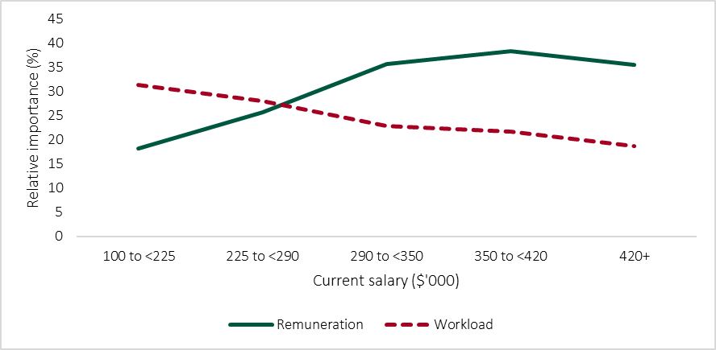

Note: Data for respondents with a current salary in the ranges of $420,000 to $579,999, $580,000 to $679,999 and $680,000+ has been combined due to low response numbers.

Source: Tribunal analysis of survey data.

Respondents who work in executive positions placed greater weight on remuneration than those who work in non-executive positions. However, survey participants with an executive-level job also had a higher average salary than those with a non-executive job.

While pay increases provide diminishing marginal utility, current salary has a large impact

As explained above and confirmed by the survey results, pay is a key factor considered by employees when choosing between jobs. The survey results are broadly consistent with the law of diminishing marginal utility — when an individual assesses job offers at a given point in time, each successive increase in remuneration provides a lower increase in utility. The results also suggest that, for at least some individuals, there is a remuneration threshold beyond which further increases have no effect on job preference.

However, the survey results show that a person’s current salary has a large impact on how they evaluate remuneration offers. This provides an important caveat to how the law of diminishing marginal utility can be applied to the topic of remuneration. For example, as Figure 6.2 shows, respondents with a current salary below $290,000 did not view a remuneration offer of $580,000 preferably to a remuneration offer of $420,000 — in fact, the lower remuneration offer was slightly preferred to the higher one. Respondents who had a current salary above $290,000 assigned a substantially higher utility to a remuneration offer of $580,000.

The ‘prospect theory’ of economics provides an explanation as to why a person’s current salary has such an impact. According to that theory, people assess gains and losses asymmetrically — the disutility (perceived harm) of losing a given amount of money is greater than the utility (perceived benefit) of gaining the same amount. According to previous studies, a loss is estimated to have around twice the influence on decisions as equivalent gains.97F[98] Broadly speaking, that theory suggests that if someone is presented with job offers that pay below their current salary, they are more likely to base their decision on remuneration than someone presented with offers paying above their current salary.

Figure 6.2: Part-worths of remuneration levels, depending on current salary

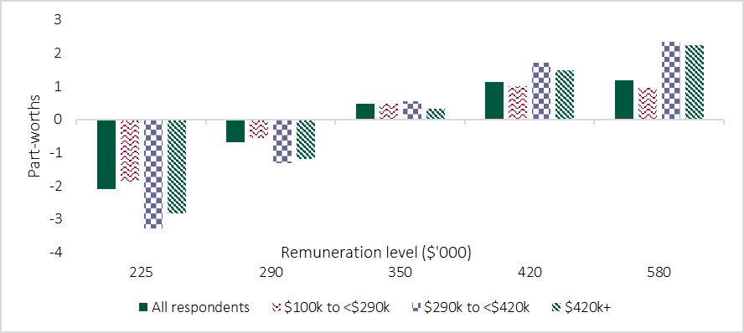

Note: To determine whether the observed differences in part-worths between respondents in each salary range were significant, the Tribunal conducted several statistical analysis of variance (ANOVA) tests. The differences were found to be significant (p<0.05) for all remuneration levels. Post hoc analysis (using Tukey’s test) showed that for all remuneration levels except $350,000, the differences were significant for all pairwise combinations of groups except for the ‘$290,000 to $419,999’ and ‘$420,000 or more’ combination. For the $350,000 level, significant differences were observed for all pairwise combinations except for the ‘$100,001 to $289,999’ and ‘$290,000 to $419,999’ combination.

Source: Tribunal analysis of survey data.

Respondents had a clear preference for public service jobs

As explained above, the results of the EVP survey show that employees consider a job’s sector when choosing between offers.

Overall, respondents substantially preferred working in the public service, followed by in a PE, not for profit and private sector. This continued to be the case even when looking at respondents working in a particular sector — for example, respondents currently working in the private sector, or for a PE, preferred public service jobs. However, the degree to which individuals working in those sectors preferred public service jobs was significantly lower (Figure 6.3).

Figure 6.3: Part-worths of sectors, depending on sector of current work

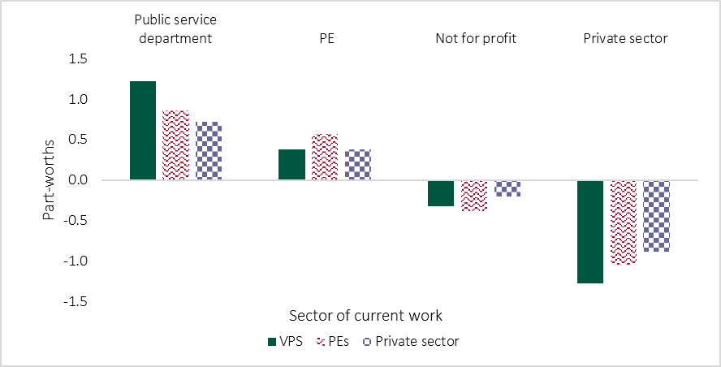

Note: To determine whether the observed differences in part-worths between respondents in different sectors were significant, the Tribunal conducted several ANOVA tests. The differences were found to be significant (p<0.05) for all levels. Post hoc analysis (using Tukey’s test) showed that public service respondents have a greater preference for public service roles compared to respondents in PEs (p<0.05) and the private sector (p<0.05), while the opposite was true for private sector roles. PE respondents were found to have a greater preference for PE roles compared to public service (p<0.05) and private sector (p<0.05) respondents. Public service (p<0.05) and PE (p<0.05) respondents were found to have a greater preference for not for profit roles than private sector respondents.

Source: Tribunal analysis of survey data.

The results suggest that, if a private sector employer wished to make a job equally appealing to candidates as an otherwise identical VPS job with a TRP of $225,000 (the base of the lowest remuneration band for VPS executives as of 1 July 2024), they would need to offer between $65,000 and $130,000 more in annual remuneration.98F[99]

When considering how an individual may value the opportunity to work in a particular sector in dollar terms, their personal circumstances and characteristics must be taken into account. The survey shows that there are large differences in how particular groups value remuneration relative to other job attributes. For example, as explained above, those with a salary of $290,000 or above saw remuneration as more important relative to other job attributes, than those with a lower current salary.

Respondents who did not currently work in the public sector were asked if they would consider a role in that sector. Of those who answered that question, around 17 per cent (43 respondents) said they were unsure and 2 per cent (5 respondents) answered no. Reasons provided for not considering a public sector role included roles not being challenging enough or the person running their own business.

Preference for public service work was positively related to public service motivation

The survey asked participants to respond to four prompts to measure their PSM. A PSM score was calculated for each participant and those scores were used to group participants into three categories: high, intermediate and low PSM (Box 6.1).

Box 6.1: Methodology used to calculate PSM score and group for respondents

|  |
| --- |
| * Responses to each of the four PSM prompts were assigned a numerical score from 0 to 4, with ‘strongly disagree’ equal to 0 and ‘strongly agree’ equal to 4. * Each individual’s overall PSM score was calculated by averaging their score across the four prompts. * Individuals were placed into a PSM group based on their PSM score:   + low PSM means a PSM score of less than 3   + intermediate PSM means a PSM score of at least 3 but less than 3.5   + high PSM means a PSM score of at least 3.5. * Groups were designed to ensure a sufficient number of respondents fell into each one for comparison purposes. |

Most respondents (62 per cent or 1,288) had a high PSM, and 28 per cent (577) had an intermediate PSM. Around 11 per cent of respondents (222) fell into the low PSM group. Respondents from the private sector were more evenly split across the three groups — 31 per cent had a high PSM, 39 per cent had an intermediate PSM and 30 per cent had a low PSM.

Respondents from the public sector had a higher average PSM score than respondents from the private sector ­— the scores were 3.56 and 3.05, respectively. The average score of respondents working in the VPS and in PEs was the same, 3.56.

Individuals with a higher PSM were expected to have a higher preference for working in the public sector, and this matched the survey results (Figure 6.4). In particular, the high PSM group preferred public service jobs more than the low PSM group, and assigned private sector work an especially low utility.

Figure 6.4: Part-worths of sectors, depending on PSM group

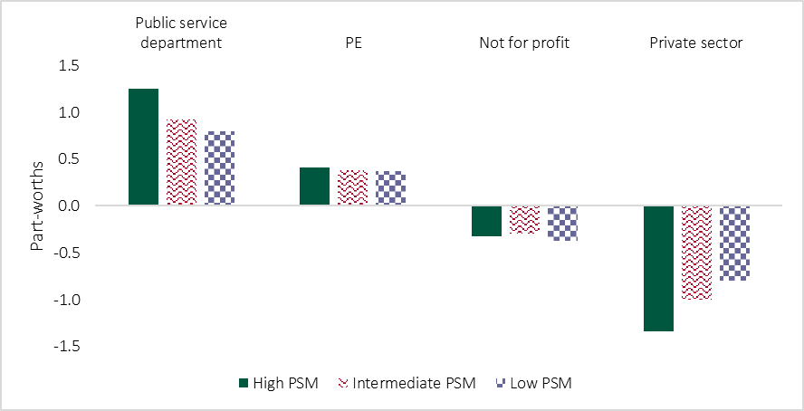

Note: To determine whether the observed differences in part-worths between PSM groups were significant, the Tribunal conducted several ANOVA tests. The differences were found to be significant for ‘public service department’ (p<0.05) and ‘private sector’ (p<0.05), while PSM was found to not have a significant effect on preferences for jobs in the PE and not for profit sectors. Post hoc analysis (using Tukey’s test) showed that there were significant differences between all groups (high-intermediate, high-low and intermediate-low) for ‘private sector’, and significant differences between two groups (high-low and high-intermediate) for ‘public service department’.

Source: Tribunal analysis of survey data.

It could reasonably be hypothesised that, after controlling for the impact of PSM, and all other things being equal, respondents would be indifferent when choosing between jobs in the public service and private sector. However, the results show that even the low PSM group preferred public service jobs to private sector jobs. This may suggest that the four prompts used in the EVP survey, which focused on serving and defending the public interest, did not capture the full range of reasons why employees may prefer to work in the public service.

While PSM had a clear effect on the degree to which respondents preferred public service and private sector jobs, it did not materially impact their views of jobs in PEs and not for profits.

The opportunity to work from home was the most valued form of flexible work

The survey included the following levels for the flexible work attribute:

* working from home up to 2 days per week
* flexible hours (compressed hours, flexible start and finish times, etc.)
* option to purchase more leave
* none specified.

Of those options, working from home was the most preferred, followed by flexible hours and the option to purchase leave (Figure 6.5).

Figure 6.5: Share of preference, flexible work options

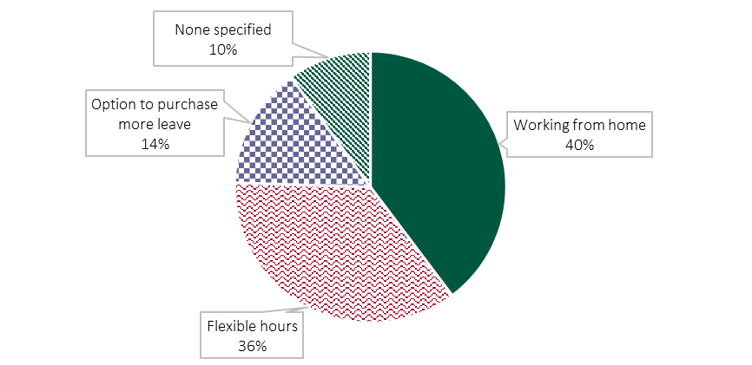

Source: Job-choice simulator developed by QuestionPro using survey data.

The survey results can be used to estimate the monetary value of flexible work options — in other words, how much more remuneration an employer would have to offer to make a job without that benefit equally appealing to an otherwise identical job that provides that benefit.

Starting from a baseline TRP of $225,000, the estimated monetary value of:99F[100]

* working from home up to 2 days per week is $50,000 to $70,000
* flexible hours is $45,000 to $65,000
* the option to purchase more leave is $10,000 to $15,000.

Respondents preferred longer contracts more than longer ‘without cause termination’ periods

The survey examined two attributes relevant to job security — the employment contract’s length and the amount of notice the employer is required to provide if they wish to terminate it early without cause.

The survey results confirmed that employees prefer longer contracts and WCT periods. Ongoing contracts were significantly preferred to fixed-term contracts. Public sector employees had a significantly greater preference for ongoing contracts than those in the private sector (Figure 6.6).

Figure 6.6: Part-worths of contract length levels, depending on sector of current work

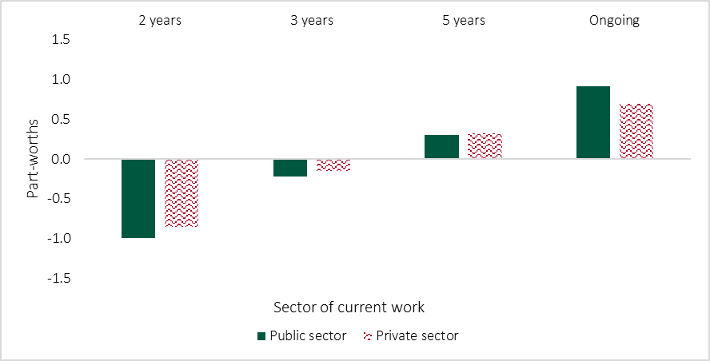

Note: The Tribunal conducted several t-tests to determine whether the part-worth values differed significantly between public and private sector respondents. The former were found to have a greater preference for ongoing contracts (p<0.05), while the latter had a greater preference for 2 year (p<0.05) and 3 year (p<0.05) contracts. The difference in part-worth values for 5 year contracts was not statistically significant (p>0.05).

Source: Tribunal analysis of survey data.

There were no statistically significant differences in part-worths for contract length between VPS and PE respondents.

Starting from a baseline TRP of $225,000, the estimated monetary value of:

* having an ongoing contract rather than a five-year contract is $15,000 to $30,000
* having a five-year contract rather than a two-year contract is $50,000 to $60,000.

Contract length preferences also varied depending on the current salary of respondents. Respondents in all salary groups preferred ongoing contracts to fixed-term contracts and preferred longer fixed-term contracts to shorter ones. However, respondents with a higher salary had a weaker preference for ongoing contracts. Respondents with a higher salary were substantially more comfortable with three-year contracts, whereas their preference for five-year and two-year contracts did not vary as much (Figure 6.7). This may suggest that executives and other senior employees are more accustomed to taking on fixed-term roles to deliver time-limited projects and regularly switching roles (e.g. every three years).

Figure 6.7: Part-worths of contract length levels, depending on current salary

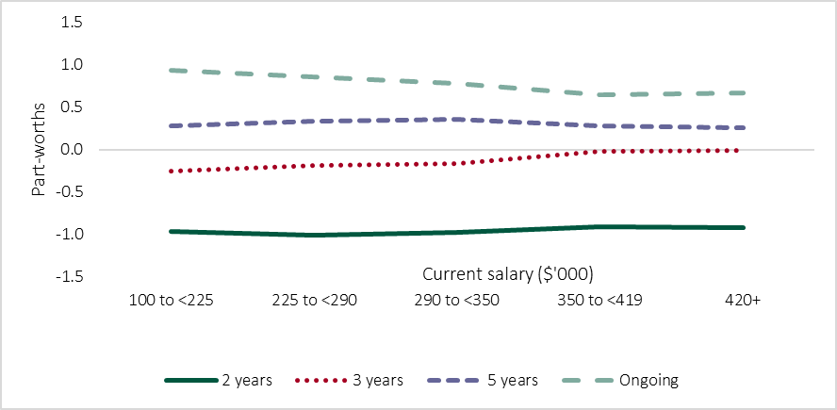

Notes: Data for respondents with a current salary in the ranges of $420,000 to $579,999, $580,000 to $679,999 and $680,000+ have been combined due to low response numbers. The Tribunal conducted several t-tests to determine whether the part-worth values differed significantly between respondents with a current salary less than $350,000 and those with a salary greater than or equal to $350,000. The latter were found to have a greater preference for 3-year contracts (p<0.05), while the former have a greater preference for ongoing contracts (p<0.05). The differences in part‑worth values for 2- and 5-year contracts were not statistically significant (p>0.05).

Source: Tribunal analysis of survey data.

The survey results indicated that respondents were more concerned about the length of a contract than the length of a WCT period. For example, the results suggest that employees would prefer a five-year contract with a four‑month WCT period rather than a two-year contract with a 12-month WCT period.

As the survey measured relative preferences for job attributes, these results should not be interpreted as evidence that the four-month WCT period for Victorian executives is appropriate, or is not a matter of concern for current and prospective executives. This is explained further in the following chapter.

The survey examined preferences for several career development opportunities

The survey included options for several types of career development opportunities. Of those examined, increased autonomy was most preferred, followed by working on high-profile or prestigious projects and acting opportunities (Figure 6.8).

Figure 6.8: Share of preference, career development opportunities

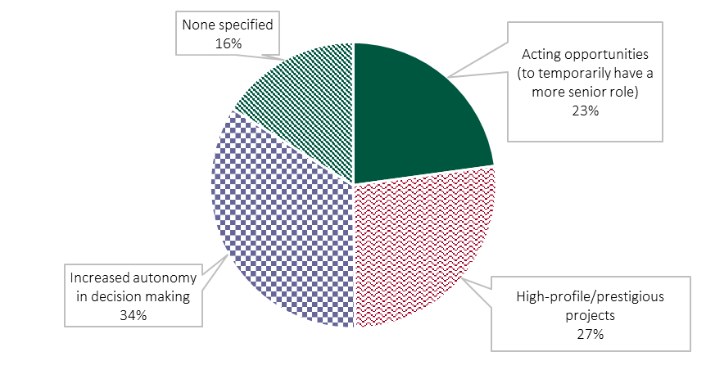

Source: Job-choice simulator developed by QuestionPro using survey data.

Gender and the type of work people do influence their preferences

Across all respondents, around 44 per cent were men (921), 52 per cent were women (1,093) and 3 per cent preferred not to say (67). Less than 1 per cent were non-binary or preferred to specify a different option (4 and 2 respondents, respectively).

As explained in Chapter 2, some previous studies found that gender affects how people value some EVP components. To test and further examine those findings, the Tribunal compared how men and women responded to the survey (Box 6.2).

Box 6.2: Differences in the survey results between men and women

|  |
| --- |
| Compared to the public sector, a greater proportion of private sector respondents were men:   * 60 per cent (134) of private sector respondents were men and 40 per cent (88) were women * 42 per cent (776) of public sector respondents were men and 54 per cent (985) were women.   Women were more likely to work part-time — 13 per cent of women (146), compared to 3 per cent of men (30).  Men were more likely to have a higher current salary than women. For example, 8 per cent of men (70) had a current salary of at least $350,000, compared to 3 per cent of women (34).  While the preferences of men and women initially appeared quite different, many of those differences may be attributable to factors other than gender, in particular, current salary and sector of work. To control for those confounding factors, the Tribunal compared the part‑worths for men and women who work in the public sector and have a current salary of $100,001 to $249,999. A few statistically significant (p<0.05) differences remained. In particular:   * women had a greater preference for flexible hours than men — the respective part‑worths were 0.65 and 0.59 * women had a greater aversion to jobs in the private sector, whereas men were more open to working in that sector — the respective part-worths were −1.37 and −1.24. |

Source: Tribunal analysis of survey data.

The Tribunal also examined whether the type of work people do affects their preferences. The survey asked respondents about the type of work they do day‑to-day. It provided 19 work-categories to choose from, including accounting and finance, community services, science, and economics. Respondents could select multiple categories.

The results suggest that the type of work individuals do and their preferences are linked. An example of this is individuals who do engineering work day-to-day (Box 6.3).

Box 6.3: Case study — job preferences of those who do engineering work day-to-day

|  |  |  |  |  |  |  |  |  |  |  |  |  |  |  |  |  |  |  |  |  |  |  |  |  |  |  |  |  |  |  |  |  |
| --- | --- | --- | --- | --- | --- | --- | --- | --- | --- | --- | --- | --- | --- | --- | --- | --- | --- | --- | --- | --- | --- | --- | --- | --- | --- | --- | --- | --- | --- | --- | --- | --- |
| Around 8 per cent of respondents (161 individuals) said they do engineering work day-to-day.  Appendix C, Figure C.4 compares the part-worths for individuals who do engineering work with those of other respondents. It shows several statistically significant differences in how those groups view career development opportunities. Compared to other employees, those who do engineering work had a:   * greater preference for working on high-profile/prestigious projects (the respective part‑worths were 0.09 and 0.24) * lower preference for acting opportunities (the respective part-worths were −0.05 and −0.13).   A higher proportion of those who do engineering work were in the private sector — around 13 per cent of private sector respondents did engineering work, compared to around 7 per cent of public sector respondents. Respondents doing engineering work were also more likely to have a higher salary.  The table below compares the relative importance of attributes for those who do engineering work and those who do not. To control for the potential effect of current salary and sector, only data for public sector respondents with a salary below $225,000 are included. The table shows that individuals who do engineering work place greater importance on remuneration and pay less attention to the job’s sector.   |  |  |  |  | | --- | --- | --- | --- | | Attribute | Engineering roles  (%) | Non-engineering roles (%) | Difference  (% points) | | Workload (per week) | 31 | 32 | −1 | | Remuneration | 22 | 16 | 6 | | Sector | 13 | 19 | -6 | | Contract length | 15 | 14 | 1 | | Flexible working options | 9 | 11 | −2 | | Career development | 6 | 5 | <1 | | WCT period (paid) | 4 | 4 | <1 |   Note: Percentages and percentage points have been rounded to the nearest whole number.  These results should be treated with caution because of a limited sample size. |

Source: Tribunal analysis of survey data.

Respondents discussed other matters they look for when choosing a job

The survey invited respondents to give free-text answers about what they look for when a choosing a new senior management job. Figure 6.9 is a word cloud generated using those answers.

Many answers raised the importance of flexibility, having a manageable workload and work-life-balance. For example, one private sector employee said:

Work-life balance is as important as remuneration.

Another private sector employee said:

Less hours and increased flexibility (including working from home) are hugely important, as well as balancing it out with salary.

Job security was also a key concern. The word ‘security’ was used 77 times in comments, and the word ‘secure’ another nine times.

An organisation’s culture (including high-performing and friendly colleagues), purpose and senior leadership were raised in many responses. One PE executive explained:

The culture of an organisation and the behaviour and leadership of senior management is very important. The tone and behaviour from the top is critical. In short, a key driver is being able to work effectively with the senior leaders of an organisation.

Several respondents mentioned being provided with a vehicle and other ‘tools of the trade’ was an important consideration.

Figure 6.9: Word cloud of answers to ‘Is there anything else you would like to tell us about what you would look for when choosing a new senior management job?’



Source: Generated from free-text survey responses using R software.

7 Key findings

P1141#yIS1

The Tribunal’s literature review and survey provide useful insights into the topics the Tribunal sought to investigate. The outcomes of this project enable the Tribunal and public sector employers to understand:

* which elements of public sector roles are relevant to their EVP, and the value ascribed to these elements by current and potential public sector executives
* the relationship between remuneration and other elements of EVP
* how current and prospective executives value working in the VPS and PEs, and how preferences should be taken into account when setting remuneration
* how those individuals value particular employment conditions, such as workload and flexible work options.

This chapter discusses the Tribunal’s key findings and observations.

As with most social behaviour research, the extent to which these findings can be generalised and used to predict people’s actions is inherently limited. Some examples of these limitations are set out in the previous chapters. Nevertheless, the Tribunal is confident that the following general findings are robust and can be relied upon. These findings are supported by strong statistical evidence, analytical modelling and a substantial body of previous research.

There is a strong public sector EVP

A key objective of the Tribunal’s survey was to determine whether and how current and prospective executives value working in the VPS and PEs. The results show that both current and prospective executives, including individuals currently working in the private sector, materially prefer jobs in the public sector. They clearly demonstrate a positive public sector EVP. This project and the Tribunal’s previous consultations show that employees associate public sector jobs, in particular those in the VPS, with the opportunity to serve the community, which is part of reason why they want to work in that sector. However, it is not the sole reason. As explained in Chapter 4, other valued features include:

* the size of the public sector and the availability of a broad range of career pathways
* a shared purpose and values
* the value of public sector experience for future employment
* work-life balance and available flexible working arrangements.

The Tribunal previously heard from stakeholders that the non-monetary benefits of working in the Victorian public sector have been matched or overtaken by other sectors. Available information shows that the private sector has matched the public sector on some non‑monetary benefits (e.g. leave entitlements). Nevertheless, the results of this project show that the Victorian public sector continues to provide non‑monetary benefits that are highly valued and taken into account when job offers are evaluated.

The findings support how the executive remuneration bands have been positioned

As explained in Chapter 1, the Tribunal has set the remuneration bands for executives with reference to the 15th percentile of the Australian General Market (AGM). That decision has been informed by its consideration of the non-monetary benefits of working in the public sector, as well as practices in other Australian jurisdictions.

For the avoidance of doubt, that does not mean that all executives are paid at the 15th percentile. Rather, it means that Victorian public sector executive remuneration is typically at the lower end of the range paid for comparable roles in other sectors. Further, public sector employers may pay an executive above the relevant remuneration band if they seek the Tribunal’s advice. That means an executive’s remuneration may be placed higher relative to the AGM where required (e.g. at the 50th percentile).

Private sector organisations commonly set their remuneration strategy with reference to the 50th percentile of the AGM.100F[101] April 2024 AGM data provided by Mercer suggests the difference between the 15th and 50th percentiles is around $110,000 for roles with a work value similar to that of a Director. For more senior roles, the difference is greater (Table 7.1)

Table 7.1: Australian General Market data, April 2024

|  |  |  |  |
| --- | --- | --- | --- |
| VPS classification  (standard title) | 15th Percentile  ($ p.a.) | 50th percentile ($ p.a.) | Difference ($) |
| Senior Executive Service-1 (Director) | 290,600 | 401,500 | 110,900 |
| Senior Executive Service-2 (Executive Director) | 418,700 | 590,700 | 172,000 |
| Senior Executive Service-3  (Deputy Secretary) | 578,300 | 809,800 | 231,500 |
| Department Secretary /  Victorian Public Sector  Commissioner | 832,800 | 1,321,700 | 488,900 |

Note: AGM data was referenced at the mid-point of the work value ranges for each classification.

Source: Mercer (2024).

The survey results suggest that, at least at the Director-level, current and potential executives are willing to forego between $65,000 and $130,000 to work in the VPS rather than the private sector, all else being equal. This suggests that remuneration bands set with the reference to the 15th percentile of the AGM should allow public sector employers to attract a sufficient pool of executive candidates to fill positions in most cases. However, it also shows that it may not be possible to fill some positions without offering remuneration above the band, for example where limited suitable candidates are available or if private sector skills are required.

The Victorian public sector is attracting executives motivated to benefit society

As discussed in Chapter 2, employers can tailor their EVP to target particular labour market segments or individuals. As serving and protecting the community is central to the work of the VPS, it makes sense for it to target high PSM individuals. The survey showed the VPS has a higher proportion of high PSM individuals, suggesting that it has appropriately tailored its EVP.

While respondents preferred jobs in both the VPS and PEs to jobs in the private sector, the preference for VPS jobs was stronger. Unlike for VPS jobs, PSM did not significantly affect the preference for PE jobs. This may indicate that employees do not associate PE jobs with the opportunity to serve the community as strongly as for VPS jobs. Victoria’s PEs play a key role in delivering vital services to the community, as well supporting the economy and cultural activities. To boost their EVP, as opportunities arise, PEs might consider reminding both their current workforce and the broader labour market of the benefits they provide to the community.

Positioning executive remuneration higher relative to the AGM would come with risks

Positioning the remuneration bands higher relative to the AGM is a consideration for attracting the best possible talent as candidates for Victorian public sector executive roles. However, that approach has some attendant risks.

While not of a high order, there is nonetheless a risk that offering higher remuneration may encourage some individuals with lower PSM — or otherwise with motivators not as well aligned with a public sector ethos — to apply for and take Victorian public sector executive roles. That is, unless carefully calibrated, the remuneration on offer might overshadow other factors for some candidates. In turn, this could impact how the employing organisation carries out its functions and how its purpose is perceived by its staff, stakeholders and the public.

Another risk is that the private and not for profit sectors may be required to increase their executive remuneration to remain competitive for talent. The survey results indicate that the private sector in particular needs to offer executives remuneration higher than that available in the public sector to attract and retain talent. Private sector organisations are reliant on different funding sources to the public sector.101F[102] As a result, different constraints apply to the remuneration these organisations are able to offer. Increasing public sector remuneration may lead to some private sector organisations being unable to afford to compete for the executive talent they require — commonly referred to as a ‘crowding out’ effect. Individuals may also choose to seek future public sector employment opportunities rather than taking private sector work — referred to as ‘queuing’.102F[103]

Employers can use the Tribunal’s findings to optimise and tailor employment offers

As discussed earlier, a person’s personal circumstances and preferences affect what they look for in a job. As the survey shows, the type of work a person does also affects how they value particular EVP components. If an employer is seeking to attract individuals with particular skills or characteristics to a role, they can use this information to tailor the role’s EVP accordingly. For example, some organisations are seeking to attract more women into executive roles to address a gender imbalance — offering benefits that women especially value is an important step to achieving that objective.

This project’s findings also suggest that offering candidates significantly higher remuneration is not an efficient way of increasing the role’s EVP, and in some cases a more modest remuneration offer would have the same effect.

Based on these findings, a remuneration strategy employers might use to optimise the EVP of job offers would be to offer candidates a modest increase in remuneration relative to their current salary, complemented by non-monetary benefits.

These findings also suggest that it is preferable for employers to provide incumbents with steady and incremental increases in pay, rather than significantly varying their pay (up and down) year to year.

However, considering someone’s previous salary when setting remuneration can entrench existing inequities, such as the gender wage gap. Employers should also be mindful of that risk and take steps to address it as part of their overall remuneration strategy.

Competitive remuneration and manageable workloads are key to attracting candidates

The survey showed that of the attributes examined, workload and remuneration had the greatest impact on job preferences. Notwithstanding employees’ preference for public sector jobs, the public sector still needs to offer competitive remuneration and manageable workloads to attract and retain staff.

During consultation for the 2024 VPS Determination, the Tribunal heard that VPS executives were required to work long hours during the COVID-19 pandemic — in some cases 12 to 18 hours a day.103F[104] Stakeholders said that while work hours had since reduced, they had not returned to pre-pandemic levels and executives were regularly working more than 50 hours per week.104F[105]

Several free-text comments to the survey stated that Victorian public sector executives continue to be required to work long hours. For example, one VPS executive said:

I would like a role where I’m required to work less than 60+ hours per week 7 days a week - which is currently required at SES1.

The survey results showed that current VPS employees, especially senior non‑executive staff, placed particular importance on a job’s hours of work and saw a 50 or 60 hour week as especially unattractive. If the work hours of VPS executives remain elevated, this may act a barrier to many non-executive VPS employees applying for executive roles and create remuneration pressures. This was reflected in the free-text comments of one PE executive, who said:

With most Exec roles working 50-70 hours per week, with little to no financial incentives or benefits, base salary needs to be well above non-exec senior manager salaries.

The survey also shows that while individuals with a current higher salary are more willing to work longer hours, they view remuneration as the most important attribute when selecting a job. As a result, filling roles with particularly long work hours may require the employer to offer high remuneration, and it may be more challenging to use non-monetary EVP factors to attract suitable candidates to those roles.

Employees greatly value flexible work options

Previous research has shown that employees greatly value the opportunity to work flexible hours or outside the office. The survey results are consistent with those findings. The VPSC’s *Flexible work policy* explains that flexible work is the government’s default position for VPS jobs, meaning that:105F[106]

* every role can have some form of flexibility
* organisations need to embed flexible work into the design and structure of their workforce
* managers must work with their employees and team to come up with solutions that work for everyone
* an employee has a meaningful level of control over when, where and how they work.

The nature of most VPS roles means that at least some flexibility is possible, and the *Flexible work policy* is an important part of their EVP. However, it must be borne in mind that some public sector roles cannot be as flexible because the nature of the role precludes it. It is important that employers consider how they can ensure those roles remain attractive and what other benefits they can provide. For example, one VPS executive said:

Ability to work from home is very important to me. Higher salary was persuasive to forgo that, but it needed to be a significant pay [increase].

Offering secure jobs helps to attract candidates

Employees consider job security when assessing job offers and in particular the length of the contract offered. The survey showed that higher paid individuals, such as current senior executives, are more comfortable with contracts with a minimum length of three years.

Where an employer needs to offer an executive employment contract of two years or less, it may need to consider what other benefits it can offer to ensure an adequate EVP is provided.

Of the seven attributes considered, WCT period had the least impact on job choice. In its 2024 VPS Determination, the Tribunal noted that the four-month WCT period in the standard VPS executive contract is substantially shorter than that provided by several other Australian jurisdictions. The Tribunal explained this discourages potential candidates from seeking employment at the executive level in Victoria, particularly in the light of increased risk and reputational damage associated with executive employment. Previous reviews have recommended the Victorian Government extend the WCT period for executives.106F[107]

While WCT period had the least impact on job choice of the seven attributes considered in the survey, the results do not mean that the current WCT period for executives is appropriate. The survey measured relative preferences for job attributes, and did not directly assess whether the existing four-month WCT period is appropriate. Further, the Tribunal notes that the import and implications of a WCT period may not be obvious to an employee that has not had it applied to them. This may have been a factor that influenced the survey results. Free‑text responses to the survey also suggest that the length of the WCT period is a topic of concern for executives. For example, one VPS executive said:

The risks within senior exec roles are increasing and there can sometimes be fears of job security that would be mitigated with longer notice periods.

Another VPS executive said:

The key thing for me is having the security [of] an ongoing position and a longer period of notice for without cause termination - it feels [like] very insecure work at the moment and in this current environment.

References

P1230#yIS1

ABS (Australian Bureau of Statistics) (2024), *Working arrangements,* August 2024*.*

Acquah A, Nsiah T, Antie E and Otoo B (2021),‘Literature review of theories motivation’, *EPRA International Journal of Economic and Business Review,* vol. 9(5).

Alshmemri M, Shahwan-Akl L and Maude P (2017), ‘Herzberg’s Two-Factor Theory’, *Life Science Journal*, vol. 14(5).

Anderfuhren-Biget S, Varone F, Giauque D and Ritz A (2010), ‘Motivating employees of the public sector: does public service motivation matter?’, *International Public Management Journal*, vol. 13(3).

Australian Council of Superannuation Investors (2023), *Governance Guidelines*, 11th edn.

Australian Human Rights Commission (2008) *Corporate Social Responsibility & Human Rights*, <https://humanrights.gov.au/our-work/publications/corporate-social-responsibility-human-rights>, accessed 26 June 2025.

Azgad-Tromer S (2017), ‘The Virtuous Corporation: On Corporate Social Motivation and Law’, *University of Pennsylvania Journal of Business Law,* vol. 19(2).

Bardoel E, Tepe S and Moss S (2003), *Is it worth it? Social factors that influence people to seek and accept senior roles,* report to the Victorian Government Office of Public Employment.

Berkman E, Kahn L and Livingston J (2016), ‘Valuation as a mechanism of self-control and ego depletion’, in Hirt E, Clarkson J and Jia L (eds), *Self-Regulation and Ego Control*.

Binu Raj A (2021), ‘Impact of employee value proposition on employees’ intention to stay: moderating role of psychological contract and social identity’, *South Asian Journal of Business Studies*, vol. 10(2).

BHP (2024) *Our Values*, <https://www.bhp.com/about/our-values>, accessed 26 June 2025.

Bloom N, Han R and Liang J (2024), ‘Hybrid working from home improves retention without damaging performance’, *Nature*, vol. 630.

Boruvka E and Perry J (2020), ‘Understanding evolving public motivational practices: An institutional analysis’, *Governance*, vol. 33(3).

Bozeman B and Su X (2015), ‘Public Service Motivation concepts and theory: A critique’, *Public Administration Review*, vol. 75(5).

Buelens M and Van den Broeck H (2007), ‘An Analysis of Differences in Work Motivation between Public and Private Sector Organizations’, *Public Administration Review*, vol. 67(1).

Cavalcanti T and Santos M (2021), ‘(Mis)allocation effects of an overpaid public sector’, *Journal of the European Economic Association*, vol. 19(2).

CEDA (Committee for Economic Development of Australia) (2025), *March 2025 WFH data insight — Australians are taking a pay cut to work from home*.

Chapman D, Uggerslev K, Carroll S, Piasentin K and Jones D (2005), ‘Applicant Attraction to Organizations and Job Choice: A Meta-Analytic Review of the Correlates of Recruiting Outcomes’, *Journal of Applied Psychology,* vol. 90(5)*.*

Chassamboulli A and Gomes P (2019), ‘Public-Sector Employment, Wages and Human Capital Accumulation’, *University of Cyprus Working Papers in Economics*, University of Cyprus Department of Economics.

Chen Y, Park J and Park A (2012), ‘Existence, relatedness, or growth? Examining turnover intention of public child welfare caseworkers from a human needs approach’, *Children and Youth Services Review*, vol. 34(10).

Clarke M and Scurry T (2017), ‘The role of the psychological contract in shaping graduate experiences: a study of public sector talent management programmes in the UK and Australia’, *The International Journal of Human Resource Management*, vol. 31(8).

Cohen D, Shin F, and Liu X (2019), ‘Meanings and Functions of Money in Different Cultural Milieus’, *Annual Review of Psychology*, vol. 70.

Commonwealth of Australia (2024), *Work with us*, <https://content.apsjobs.gov.au/work-with-us>, accessed 30 July 2025.

Department of Health (2024), *Improving the employee experience*, <https://www.health.vic.gov.au/health-workforce/improving-the-employee-experience>, accessed 30 July 2025.

Egan Associates (n.d.), *When is shareholder approval required for the provision of a termination payment?*, <https://eganassociates.com.au/when-is-shareholder-approval-required-for-the-provision-of-a-termination-payment/>, accessed 27 June 2025.

Fair Work Obudsman (n.d.), *Notice of termination and redundancy pay*, <https://www.fairwork.gov.au/tools-and-resources/fact-sheets/minimum-workplace-entitlements/notice-of-termination-and-redundancy-pay>, accessed 27 June 2025.

Fennessy A (2022), *Who would want to be a public sector CEO?*, <https://anzsog.edu.au/news/who-would-want-to-be-a-public-sector-ceo/>, accessed 27 June 2025.

Gartner (2018), *Global Talent Monitor, Update on workforce activity that occurred in Q4 2017.*

——— (2019), *Global Talent Monitor 3Q19: Update on Workforce Activity*.

——— (2024), *Gartner HR Survey Finds Australian Employees Are Looking for Career and Organizational Stability in 2024*, [https://www.gartner.com/en/  
newsroom/press-releases/2024-02-14-gartner-hr-survey-finds-australian-employees-are-looking-for-career-and-organizational-stability-in-2024](https://www.gartner.com/en/newsroom/press-releases/2024-02-14-gartner-hr-survey-finds-australian-employees-are-looking-for-career-and-organizational-stability-in-2024), accessed 18 August 2025.

——— (2025) *Gartner HR Survey Finds Australian Employee Financial Wellness Hits Three-Year Low*, <https://www.gartner.com/en/newsroom/press-releases/2025-04-30-gartner-hr-survey-finds-australian-employee-financial-wellness-hits-3-year-low>, accessed 8 July 2025.

Gitman L, McDaniel C, Shah A, Reece M, Koffel L, Talsma B and Hyatt J (2018) *Introduction to Business*.

Glassdoor (2019), *New Survey: Company Mission & Culture Matter More Than Compensation*, <https://www.glassdoor.com/blog/mission-culture-survey/>, accessed 21 July 2025.

Harvard Division of Continuing Education (2025), *Why Workplace Culture Matters*, <https://professional.dce.harvard.edu/blog/why-workplace-culture-matters/#What-is-Positive-Workplace-Culture>, accessed 21 July 2025.

Hays (2025), *Hays salary guide FY25/26*.

Head B and Colley L (2021), *Senior Executive Service Case Study – Victoria*, Australia and New Zealand School of Government.

Hill J, Masulis R and Thomas R (2011), ‘Comparing CEO Employment Contract Provisions: Differences Between Australian and the United States’, *Vanderbilt Law Review*, vol. 64(2).

Hinna A, Homberg F, Scarozza D, and Verdini V (2021), ‘Public service motivation and public sector employment preference: Comparing Italian and British students’, *Public Money & Management*, vol. 41(1).

Hu J and Hirsh J (2017), ‘Accepting Lower Salaries for Meaningful Work’, *Frontiers in Psychology,* vol. 8.

Johnston K (2025), ‘New development: Is it time for New Public Service Bargain?’*, Public Money & Management,* vol. 45(2).

Kurt S (2023), *Education Library, Alderfer’s ERG Theory*, <https://educationlibrary.org/alderfers-erg-theory/>, accessed 21 July 2025.

Lapuente V and Van de Walle S (2020), ‘The effects of new public management on the quality of public services’, *Governance*, vol. 33(3).

Latham G and Pinder C (2005), ‘Work motivation theory and research at the dawn of the twenty-first century’, *Annual Review of Psychology*, vol. 56(1).

Melbourne Water (n.d.a), *Careers*, [https://www.melbournewater.com.au  
/about/careers](https://www.melbournewater.com.au/about/careers), accessed 30 July 2025.

——— (n.d.b), *Who we are*, <https://www.melbournewater.com.au/about/who-we-are>, accessed 30 July 2025.

Meng F and Wu J (2017), ‘Policy expectation moderates the relationship between merit pay policy effectiveness and public service motivation’, *Social Behavior and Personality*, vol. 45(8).

Mercer (2024), *Executive Remuneration Benchmarking and Advice – Secretary and Senior Executive Service*, report to the Victorian Independent Remuneration Tribunal.

Milkovich G, Newman J and Gerhart B (2014), *Compensation*, 11th edition.

Miller S (2015), *85% of companies targeted market median for base pay*, <https://www.shrm.org/topics-tools/news/benefits-compensation/85-companies-targeted-market-median-base-pay>, accessed 31 July 2025.

New South Wales Government Public Service Commission (2025), *Employee value proposition*, [https://www.psc.nsw.gov.au/workforce-management/  
recruitment/employee-value-proposition](https://www.psc.nsw.gov.au/workforce-management/recruitment/employee-value-proposition), accessed 30 July 2025.

O’Reilly C and Chatman J (1996), ‘Culture and social control: Corporations, cult and commitment’, *Research in Organisational Behaviour*, vol. 18.

Orme B (2010), *Getting Started with Conjoint Analysis, Strategies for Product Design and Pricing Research*, 2nd edn.

Panneerselvam S and Balaraman K (2022), ‘Employee Experience: the new employee value proposition’, *Strategic HR Review*, vol. 21(6).

Perry J and Wise L (1990), ‘The motivational bases of public service’, *Public Administration Review,* vol. 50.

Productivity Commission (2009), *Executive Remuneration in Australia*.

PwC (2021), *The Future of Work* — *What workers want: Winning the war for talent*.

QuestionPro (n.d.), *Conjoint Analysis – Attribute Importance*, <https://www.questionpro.com/help/conjoint-analysis-attribute-importance.html>, accessed 8 July 2025.

Ripoll G, Ballart X, Hernández E, and Vandenabeele W (2023), ‘It’s a match!: a discrete choice experiment on job attractiveness for public service jobs’, *Public Management Review*, vol. 27(1).

Ronda L, Abril C and Valor C (2020) ‘Job choice decisions: understanding the role of nonnegotiable attributes and trade-offs in effective segmentation’, *Management Decision*, vol. 59(6).

State Government of Queensland (2025), *#BeHere4Qld, 5 top reasons to work for Queensland*, <https://psc.qld.gov.au/behere4qld/top-reasons>, accessed 30 July 2025.

State Government of Victoria (2024), *Public entity executive remuneration policy*, <https://www.vic.gov.au/public-entity-executive-remuneration-policy>, accessed 22 July 2025.

State Services Authority (2006), *The future of the public sector in 2025*.

Sull D, Sull C and Chamberlain A (2019), *Measuring Culture in Leading Companies, Introducing the MIT SMR/Glassdoor Culture 500*, <https://sloanreview.mit.edu/projects/measuring-culture-in-leading-companies/>, accessed 21 July 2025.

Theys N and Barkhuizen E (2022), ‘The development of an employee value proposition framework for the South African water board sector’, *SA Journal of Human Resource Management*, vol. 20.

United Nations Development Programme Global Centre for Public Service Excellence (2015), *From Old Public Administration to the New Public service, Implications for public Sector Reform in Developing Countries*.

Van Triest S (2024), ‘Incentives and effort in the public and private sector’, *Public Administration Review*, vol. 84(2).

Van Tuin L, Schaufeli W, Van den Broeck A and Van Rhenen W (2020), ‘A Corporate Purpose as an Antecedent to Employee Motivation and Work Engagement’, *Frontiers in Psychology* vol. 11.

Vandenabeele W and Penning de Vries J (2016), *A global measure of public service motivation: comparing a global scale of PSM to the Kim et al measure*, paper presented at the 20th International Research Society on Public Management Conference 2016, Hong Kong.

VFMC (Victorian Funds Management Corporation) (n.d.a), *Balanced Lives*, <https://www.vfmc.vic.gov.au/why-join-vfmc/balanced-lives/>, accessed 30 July 2025.

——— (n.d.b), *Life @ VFMC*, <https://www.vfmc.vic.gov.au/why-join-vfmc/life-vfmc/>, accessed 30 July 2025.

Victorian Auditor-General’s Office (2005), *In good hands: Smart recruiting for a capable public sector*.

Victorian Independent Remuneration Tribunal (2020), *Review and report on the superannuation arrangements for Members of the Parliament of Victoria*.

——— (2024a), *Remuneration bands for executives employed in prescribed public entities (Victoria) determination No. 01/2024*.

——— (2024b), *Remuneration bands for executives employed in public service bodies (Victoria) determination No. 01/2024*.

Vij A, Souza F, Barrie H, Anilan V, Sarmiento S and Washington L (2023), ‘Employee preferences for working from home in Australia’, *Journal of Economic Behavior & Organization*, vol. 214.

Vogel R and Satzger M (2024), ‘What drives the attractiveness of public and private employers? Comparative evidence from an online employer review platform’, *The American Review of Public Administration*, vol. 54(2).

VPSC (Victorian Public Sector Commission) (2021), *Standard contract for VPS executives*.

——— (2022), *Flexible work policy*, <https://www.vpsc.vic.gov.au/workforce-capability-leadership-and-management/flexible-work/flexible-work-policy/>, accessed 2 July 2025.

——— (2025) *History of public administration in Victoria*, <https://vpsc.vic.gov.au/about-public-sector/public-administration-in-victoria/>, accessed 22 August 2025.

Walasek L, Mullett T and Stewart N (2024), ‘A meta-analysis of loss aversion in risky contexts’, *Journal of Economic Psychology*, vol. 103.

Ward S (2024), ‘Choosing Money Over Meaningful Work: Examining Relative Job Preferences for High Compensation Versus Meaningful Work’, *Personality and Social Psychology Bulletin*, vol. 50(7).

WGEA (Workplace Gender Equality Agency) (2024), *Australia’s Gender Equality Scorecard*.

World Bank (2021), *Worldwide Bureaucracy Indicators: Methodology, Insights, and Applications*.

Yang Y and Ling Q (2023), ‘The influence of existence-relatedness-growth need satisfaction and job burnout of young university teachers: the mediating role of job satisfaction*’, Frontiers in Psychology,* vol. 14.

Appendix A — survey questions

P1316#yIS1

Introduction

Who, What and Why

* This survey will take about 10 minutes and will ask questions about your current work and future roles you might consider.
* The Victorian Independent Remuneration Tribunal invites you to complete this survey, which is part of a non-commercial study it is undertaking.
* The Tribunal is an independent Victorian public sector agency. As part of its functions, the Tribunal may conduct reviews and publish reports on executive remuneration trends in the public sector.
* Your participation will help the Tribunal better understand the factors that people consider when choosing between senior management job offers.

Further information

* Your participation in this study is voluntary and can be terminated at any time and without giving reasons.
* Your data will be handled in accordance with all relevant Australian State and Commonwealth privacy laws and the Victorian Independent Remuneration Tribunal's [privacy policy](https://www.vic.gov.au/virt-privacy-policy).

How we collect and use your data

* Data we collect in this study is collected anonymously – your identity is not provided to us or recorded in the data file.
* Your anonymous responses will be stored permanently for future research or non-commercial use.
* Conclusions about you as an individual or other people are not possible.
* The data (which carries no identifying information) may be provided to public policymakers to help inform future decision-making and priorities.
* I agree to participate in this survey. I agree to the processing of my personal data in accordance with the information provided here.
* I do NOT want to participate [survey ends]

About you

First, we would like to understand a bit about your current work.

1. How would you describe the sector you currently work in?
   1. Public sector (i.e. government)
   2. Private sector (i.e. for profit business)
   3. Not for profit
   4. I am currently studying, retired, looking for work, or not working [survey ends]
   5. Other (please specify)
2. [Question asked if ‘Public sector’ selected in question 1] Where do you currently work?
   1. A Victorian public service body (department, administrative office or Victorian Public Sector Commission)
   2. A Victorian public entity
   3. Local government
   4. Commonwealth public sector
   5. Other State or Territory public sector
   6. Other (please specify)
3. How many years in total have you been with your current organisation (at any level)? If you currently work in the public sector, please include any years you have spent with your current department or entity.
   1. Less than 5 years
   2. 5-9 years
   3. 10-14 years
   4. 15-19 years
   5. 20-24 years
   6. 25 years or more
4. [Question asked if ‘Private sector’, ‘Not for profit sector’ or ‘Other’ selected in question 1 or ‘Local government’ selected in question 2] What is your current level of seniority? If you are acting in a role, please respond based on your acting role.
   1. Non-executive employee not in a management role [survey ends]
   2. Chief Executive or equivalent or other C-suite executive
   3. Other senior manager or leader
   4. Other (please specify)
5. [Question asked if ‘A Victorian public service body’ selected in question 2] What is your current VPS classification? If you are acting in a different classification, please respond based on your acting position.
   1. VPS 1-3 (or equivalent) [survey ends]
   2. VPS 4-5 (or equivalent) [survey ends]
   3. VPS 6 (or equivalent)
   4. VPS 7 (Senior Technical Specialist) (or equivalent)
   5. Senior Executive Service-1 or Administrative Office Head-1 (or equivalent)
   6. Senior Executive Service-2 or Administrative Office Head-2 (or equivalent)
   7. Senior Executive Service-3 or Administrative Office Head-3 (or equivalent)
6. [Question asked if ‘A Victorian public entity’ selected in question 2] What is your current classification? If you are acting in a different classification, please respond based on your acting position.
   1. Non-executive employee not in a management role [survey ends]
   2. Non-executive employee in a management role
   3. Public Entity Senior Executive Service-1 or Senior Executive Service-1
   4. Public Entity Senior Executive Service-2 or Senior Executive Service-2
   5. Public Entity Senior Executive Service-3 or Senior Executive Service-3
7. [Question asked if ‘Commonwealth public sector’, ‘Other State or Territory public sector’ or ‘Other’ selected in question 2] What is your current level of seniority? If you are acting in a role, please respond based on your acting role.
   1. Non-executive employee not in a management role [survey ends]
   2. Non-executive employee in a management role
   3. Executive employee
   4. Other (please specify)
8. What is your current yearly salary (including super, before tax)?
   1. Less than $100,000 [survey ends]
   2. $100,001 to $224,999
   3. $225,000 to $289,999
   4. $290,000 to $349,999
   5. $350,000 to $419,999
   6. $420,000 to $579,999
   7. $580,000 to $679,999
   8. Over $680,000
   9. Prefer not to say
9. [Question asked if ‘Private sector’, ‘Not for profit’ or ‘Other’ selected in question 1] In general, would you consider a role in the public sector?
   1. Yes
   2. No
   3. Unsure
10. [Question asked if ‘No’ selected in question 9] Why would you not consider a role in the public sector?
    1. Public sector pay is too low
    2. I am not interested in public sector work
    3. My skills would not be adequately recognised in the public sector
    4. Lack of bonus opportunities in the public sector
    5. Lack of non-financial benefits in the public sector
    6. Limited career progression or professional development opportunities in the public sector
    7. My current type of role does not exist / is hard to find in the public sector
    8. Other
11. Which of these options best describes the type of work you do day-to-day? Select all that apply.
    1. Accounting and finance
    2. Administration
    3. Business services
    4. Communications and community engagement
    5. Community services
    6. Data analytics and research
    7. Digital and technology
    8. Economics
    9. Emergency management
    10. Engineering
    11. Health
    12. Human resources
    13. Legal
    14. Policy and strategy
    15. Project and program management
    16. Regulation, governance, and risk
    17. Science
    18. Service delivery to the public (e.g. teaching, customer support or corrections)
    19. Other (please describe)
12. Which of the following statements best describes your intentions for your current role?
    1. I am actively looking for a new role
    2. I have considered looking for a new role / am open to offers
    3. I have not considered looking for a new role
    4. Prefer not to say
13. How strongly do you agree or disagree with each of the following statements?

|  |  |  |  |  |  |
| --- | --- | --- | --- | --- | --- |
|  | Strongly agree | Agree | Neutral | Disagree | Strongly disagree |
| I am very motivated to contribute to society | ❏ | ❏ | ❏ | ❏ | ❏ |
| I find it very motivating to contribute to society | ❏ | ❏ | ❏ | ❏ | ❏ |
| Making a difference in society, no matter how small, is very important to me | ❏ | ❏ | ❏ | ❏ | ❏ |
| Acting in the public interest is very important to me | ❏ | ❏ | ❏ | ❏ | ❏ |

Choice model task

We would now like you to choose between different job offers.

There will be several different types of offers shown to you, each time please pick the one you like most – or if none appeal then select ‘none’.

If you were looking for a **new senior management job** today, which of the below would you choose?

[*Participant is shown four possible roles and an option for none of the above. Repeated five times*. *Attributes and levels for the choice model task are shown below*]

| **Attribute** | **Level** | **Level** | **Level** | **Level** | **Level** |
| --- | --- | --- | --- | --- | --- |
| Remuneration | $225,000 | $290,000 | $350,000 | $420,000 | $580,000 |
| Sector | Public service department (e.g. Health, Education) | Public entity (e.g. Water Authority, TAFEs) | Private sector | Not for profit |  |
| Career development | Acting opportunities (to temporarily have a more senior role) | Increased autonomy in decision making | High-profile/ prestigious projects | None specified |  |
| Workload per week | 40 hours | 50 hours | 60 hours |  |  |
| Flexible working options | Flexible hours (start and finish times, compressed hours, etc.) | Working from home (up to 2 days per week) | Option to purchase more leave | None specified |  |
| Without cause termination period (paid) | 4 months | 6 months | 9 months | 12 months |  |
| Contract length | 2 years | 3 years | 5 years | Ongoing |  |

1. Is there anything else you would like to tell us about what you would look for when choosing a new senior management job?

Demographics

1. How do you describe your gender?
   1. Woman
   2. Man
   3. Non-binary
   4. Prefer to specify (please specify)
   5. Prefer not to say
2. How old are you?
   1. Under 18
   2. 18-24
   3. 25-34
   4. 35-44
   5. 45-54
   6. 55-64
   7. Above 64
3. Where do you currently live?
   1. Melbourne CBD
   2. Melbourne suburbs
   3. Regional city
   4. Location in Victoria outside of a regional city
   5. Outside Victoria
   6. Other (please specify)
4. Where have you primarily worked from for the last 3 months?   
   If you work in more than one location, select the primary or ‘base’ location.
   1. Melbourne CBD
   2. Melbourne suburbs
   3. Regional city
   4. Location in Victoria outside of a regional city
   5. Outside Victoria
   6. Other (please specify)
5. What have been your main places of work over the last 3 months? Please select all that apply.
   1. Your employer’s office
   2. Home or private location
   3. A frontline or service delivery location (including working on site)
   4. A shared office space (where two or more organisations share the same workspace)
   5. Other (please specify)
6. Do you currently work…
   1. Full-time
   2. Part-time
   3. Full-time, but I would like to work part-time
   4. Part-time, but I would like to work full-time
   5. Other (please specify)

Appendix B — summary of survey data about respondents

P1565#yIS1

The Tribunal’s survey asked respondents about their current job and demographics. Responses from individuals who were included in the final data set are summarised below.

Responses that were excluded from the final data set are not shown in this summary. Responses were excluded if, based on the answers provided, the respondent was not part of the survey’s target audience. Some responses were also removed based on quality-control checks, for example, if the respondent completed the survey too quickly.

Table B.1: How would you describe the sector you currently work in?

|  |  |  |
| --- | --- | --- |
| Answer choices | Number of responses | % |
| Public sector (i.e. government) | 1,830 | 88 |
| Private sector (i.e. for profit business) | 224 | 11 |
| Not for profit | 26 | 1 |
| Other | 7 | <1 |
| Total | 2,087 | 100 |

Note: Percentages have been rounded to the nearest whole number.

Table B.2: For respondents working in the public sector — Where do you currently work?

|  |  |  |
| --- | --- | --- |
| Answer choices | Number of responses | % |
| VPS | 1,556 | 75 |
| Public Entity | 257 | 12 |
| Other State or Territory Public Sector | 6 | <1 |
| Other | 6 | <1 |
| Local government | 4 | <1 |
| Commonwealth public sector | 1 | <1 |
| Total | 1,830 | 88 |

Note: Percentages have been rounded to the nearest whole number. The sum of the percentages in this table does not reach 100 per cent as the question was only presented to a sub-set of respondents.

Table B.3: How many years in total have you been with your current organisation (at any level)? If you currently work in the public sector, please include any years you have spent with your current department or entity.

|  |  |  |
| --- | --- | --- |
| Answer choices | Number of responses | % |
| Less than 5 years | 840 | 40 |
| 5-9 years | 604 | 29 |
| 10-14 years | 252 | 12 |
| 15-19 years | 173 | 8 |
| 20-24 years | 108 | 5 |
| 25 years or more | 110 | 5 |
| Total | 2,087 | 100 |

Note: Percentages have been rounded to the nearest whole number. The sum of the percentages in this table does not reach 100 per cent as the question was only presented to a sub-set of respondents.

Table B.4: For respondents working in the private, not for profit or local government sectors or who picked ‘Other’ when asked about their sector of work — What is your current level of seniority? If you are acting in a role, please respond based on your acting role.

|  |  |  |
| --- | --- | --- |
| Answer choices | Number of responses | % |
| Other senior manager or leader | 179 | 9 |
| Chief Executive or equivalent or other C-suite executive | 58 | 3 |
| Other | 24 | 1 |
| Total | 261 | 13 |

Note: Percentages have been rounded to the nearest whole number. The sum of the percentages in this table does not reach 100 per cent as the question was only presented to a sub-set of respondents.

Table B.5: For respondents working in the VPS — What is your current VPS classification? If you are acting in a different classification, please respond based on your acting position.

|  |  |  |
| --- | --- | --- |
| Answer choices | Number of responses | % |
| VPS 6 (or equivalent) | 823 | 39 |
| VPS Grade 7 / Senior Technical Specialist (or equivalent) | 233 | 11 |
| Senior Executive Service-1 or Administrative Office Head-1  (or equivalent) | 286 | 14 |
| Senior Executive Service-2 or Administrative Office Head-2  (or equivalent) | 189 | 9 |
| Senior Executive Service-3 or Administrative Office Head-3  (or equivalent) | 25 | 1 |
| Total | 1,556 | 75 |

Note: Percentages have been rounded to the nearest whole number. The sum of the percentages in this table does not reach 100 per cent as the question was only presented to a sub-set of respondents.

Table B.6: For respondents working in a public entity — What is your current classification? If you are acting in a different classification, please respond based on your acting position.

|  |  |  |
| --- | --- | --- |
| Answer choices | Number of responses | % |
| Non-executive employee in a management role | 65 | 3 |
| Public Entity Senior Executive Service-1 or Senior Executive Service-1 | 100 | 5 |
| Public Entity Senior Executive Service-2 or Senior Executive Service-2 | 73 | 3 |
| Public Entity Senior Executive Service-3 or Senior Executive Service-3 | 19 | 1 |
| Total | 257 | 12 |

Note: Percentages have been rounded to the nearest whole number. The sum of the percentages in this table does not reach 100 per cent as the question was only presented to a sub-set of respondents.

Table B.7: For respondents working in a different public sector — What is your current level of seniority? If you are acting in a role, please respond based on your acting role.

|  |  |  |
| --- | --- | --- |
| Answer choices | Number of responses | % |
| Executive employee | 7 | <1 |
| Non-executive employee in a management role | 6 | <1 |
| Total | 13 | 1 |

Note: Percentages have been rounded to the nearest whole number. The sum of the percentages in this table does not reach 100 per cent as the question was only presented to a sub-set of respondents. Respondents comprised those who selected ‘Commonwealth public sector’, ‘Other State or Territory Public Sector’ or ‘Other’ in the question shown in Table B.2.

Table B.8: What is your current yearly salary (including super, before tax)?

|  |  |  |
| --- | --- | --- |
| Answer choices | Number of responses | % |
| $100,001 to $224,999 | 1,229 | 59 |
| $225,000 to $289,999 | 474 | 23 |
| $290,000 to $349,999 | 212 | 10 |
| $350,000 to $419,999 | 58 | 3 |
| $420,000 to $579,999 | 40 | 2 |
| $580,000 to $679,999 | 5 | <1 |
| Over $680,000 | 4 | <1 |
| Prefer not to say | 65 | 3 |
| Total | 2,087 | 100 |

Note: Percentages have been rounded to the nearest whole number.

Table B.9: For respondents not working in the public sector — In general, would you consider a role in the public sector?

|  |  |  |
| --- | --- | --- |
| Answer choices | Number of responses | % |
| Yes | 209 | 10 |
| Unsure | 43 | 2 |
| No | 5 | <1 |
| Total | 257 | 12 |

Note: Percentages have been rounded to the nearest whole number. The sum of the percentages in this table does not reach 100 per cent as the question was only presented to a sub-set of respondents. Respondents comprised those who selected ‘Private sector’, ‘Not for profit’ or ‘Other’ in the question shown in Table B.1.

Table B.10: For respondents who answered ‘no’ to previous question — Why would you not consider a role in the public sector?

|  |  |  |
| --- | --- | --- |
| Answer choices | Number of responses | % |
| Other | 5 | <1 |
| Public sector pay is too low | 0 | 0 |
| I am not interested in public sector work | 0 | 0 |
| My skills would not be adequately recognised in the public sector | 0 | 0 |
| Lack of bonus opportunities in the public sector | 0 | 0 |
| Lack of non-financial benefits in the public sector | 0 | 0 |
| Limited career progression or professional development opportunities in the public sector | 0 | 0 |
| My current type of role does not exist / is hard to find in the public sector | 0 | 0 |
| Total | 5 | <1 |

Note: Percentages have been rounded to the nearest whole number. The sum of the percentages in this table does not reach 100 per cent as the question was only presented to a sub-set of respondents.

Table B.11: Which of these options best describes the type of work you do day-to-day? Select all that apply.

| Answer choices | Number of responses | % |
| --- | --- | --- |
| Accounting and finance | 223 | 11 |
| Administration | 361 | 17 |
| Business services | 236 | 11 |
| Communications and community engagement | 236 | 11 |
| Community services | 123 | 6 |
| Data analytics and research | 241 | 12 |
| Digital and technology | 282 | 14 |
| Economics | 71 | 3 |
| Emergency management | 127 | 6 |
| Engineering | 161 | 8 |
| Health | 87 | 4 |
| Human resources | 224 | 11 |
| Legal | 170 | 8 |
| Policy and strategy | 693 | 33 |
| Project and program management | 790 | 38 |
| Regulation, governance and risk | 513 | 25 |
| Science | 50 | 2 |
| Service delivery to the public (e.g. teaching, customer support or corrections) | 211 | 10 |
| Other | 137 | 7 |
| Total respondents | 2,087 |  |

Note: Percentages have been rounded to the nearest whole number. The sum of the percentages in this table exceeds 100 as respondents were able to select more than one option.

Table B.12: Which of the following statements best describes your intentions for your current role?

|  |  |  |
| --- | --- | --- |
| Answer choices | Number of responses | % |
| I have considered looking for a new role/am open to offers | 1,134 | 54 |
| I have not considered looking for a new role | 627 | 30 |
| I am actively looking for a new role | 267 | 13 |
| Prefer not to say | 59 | 3 |
| Total | 2,087 | 100 |

Note: Percentages have been rounded to the nearest whole number.

Table B.13: How strongly do you agree or disagree with the statement “I am very motivated to contribute to society”?

|  |  |  |
| --- | --- | --- |
| Answer choices | Number of responses | % |
| Strongly agree | 1,239 | 59 |
| Agree | 730 | 35 |
| Neutral | 96 | 5 |
| Disagree | 10 | <1 |
| Strongly disagree | 12 | 1 |
| Total | 2,087 | 100 |

Note: Percentages have been rounded to the nearest whole number.

Table B.14: How strongly do you agree or disagree with the statement “I find it very motivating to contribute to society”?

|  |  |  |
| --- | --- | --- |
| Answer choices | Number of responses | % |
| Strongly agree | 1,243 | 60 |
| Agree | 711 | 34 |
| Neutral | 113 | 5 |
| Disagree | 7 | <1 |
| Strongly disagree | 13 | 1 |
| Total | 2,087 | 100 |

Note: Percentages have been rounded to the nearest whole number.

Table B.15: How strongly do you agree or disagree with the statement “Making a difference in society, no matter how small, is very important to me”?

|  |  |  |
| --- | --- | --- |
| Answer choices | Number of responses | % |
| Strongly agree | 1,079 | 52 |
| Agree | 802 | 38 |
| Neutral | 166 | 8 |
| Disagree | 27 | 1 |
| Strongly disagree | 13 | 1 |
| Total | 2,087 | 100 |

Note: Percentages have been rounded to the nearest whole number.

Table B.16: How strongly do you agree or disagree with the statement “Acting in the public interest is very important to me”?

|  |  |  |
| --- | --- | --- |
| Answer choices | Number of responses | % |
| Strongly agree | 1,350 | 65 |
| Agree | 628 | 30 |
| Neutral | 91 | 4 |
| Disagree | 8 | <1 |
| Strongly disagree | 10 | <1 |
| Total | 2,087 | 100 |

Note: Percentages have been rounded to the nearest whole number.

Table B.17: How do you describe your gender?

|  |  |  |
| --- | --- | --- |
| Answer choices | Number of responses | % |
| Woman | 1,093 | 52 |
| Man | 921 | 44 |
| Prefer not to say | 67 | 3 |
| Non-binary | 4 | <1 |
| Prefer to specify | 2 | <1 |
| Total | 2,087 | 100 |

Note: Percentages have been rounded to the nearest whole number.

Table B.18: How old are you?

|  |  |  |
| --- | --- | --- |
| Answer choices | Number of responses | % |
| 18-24 | 6 | <1 |
| 25-34 | 158 | 8 |
| 35-44 | 728 | 35 |
| 45-54 | 791 | 38 |
| 55-64 | 355 | 17 |
| above 65 | 47 | 2 |
| Total | 2,087 | 100 |

Note: Percentages have been rounded to the nearest whole number.

Table B.19: Where do you currently live?

|  |  |  |
| --- | --- | --- |
| Answer choices | Number of responses | % |
| Melbourne suburbs | 1,505 | 72 |
| Melbourne CBD | 224 | 11 |
| Regional city | 207 | 10 |
| Location in Victoria outside of a regional city | 142 | 7 |
| Outside Victoria | 6 | <1 |
| Other | 3 | <1 |
| Total | 2,087 | 100 |

Note: Percentages have been rounded to the nearest whole number.

Table B.20: Where have you have primarily worked from for the last 3 months? If you work in more than one location, select the primary or ‘base’ location?

|  |  |  |
| --- | --- | --- |
| Answer choices | Number of responses | % |
| Melbourne suburbs | 489 | 23 |
| Melbourne CBD | 1,321 | 63 |
| Regional city | 182 | 9 |
| Location in Victoria outside of a regional city | 82 | 4 |
| Outside Victoria | 13 | 1 |
| Total | 2,087 | 100 |

Note: Percentages have been rounded to the nearest whole number.

Table B.21: What have been your main places of work over the last 3 months? Please select all that apply.

|  |  |  |
| --- | --- | --- |
| Answer choices | Number of responses | % |
| Your employer’s office | 1,772 | 85 |
| Home or private location | 1,322 | 63 |
| A frontline or service delivery location (including working on site) | 165 | 8 |
| A shared office space (where two or more organisations share the same workspace) | 72 | 3 |
| Other | 14 | 1 |
| Total respondents | 2,087 |  |

Note: Percentages have been rounded to the nearest whole number. The sum of the percentages in this table exceeds 100 as respondents were able to select more than one option.

Table B.22: Do you currently work…?

|  |  |  |
| --- | --- | --- |
| Answer choices | Number of responses | % |
| Full-time | 1,851 | 89 |
| Part-time | 174 | 8 |
| Full-time, but I would like to work part-time | 51 | 2 |
| Part-time, but I would like to work full-time | 7 | <1 |
| Other | 4 | <1 |
| Total | 2,087 | 100 |

Note: Percentages have been rounded to the nearest whole number.

Appendix C — part-worths from choice-based conjoint exercise

P2354#yIS1

Figure C.1: Average part-worths, all respondents

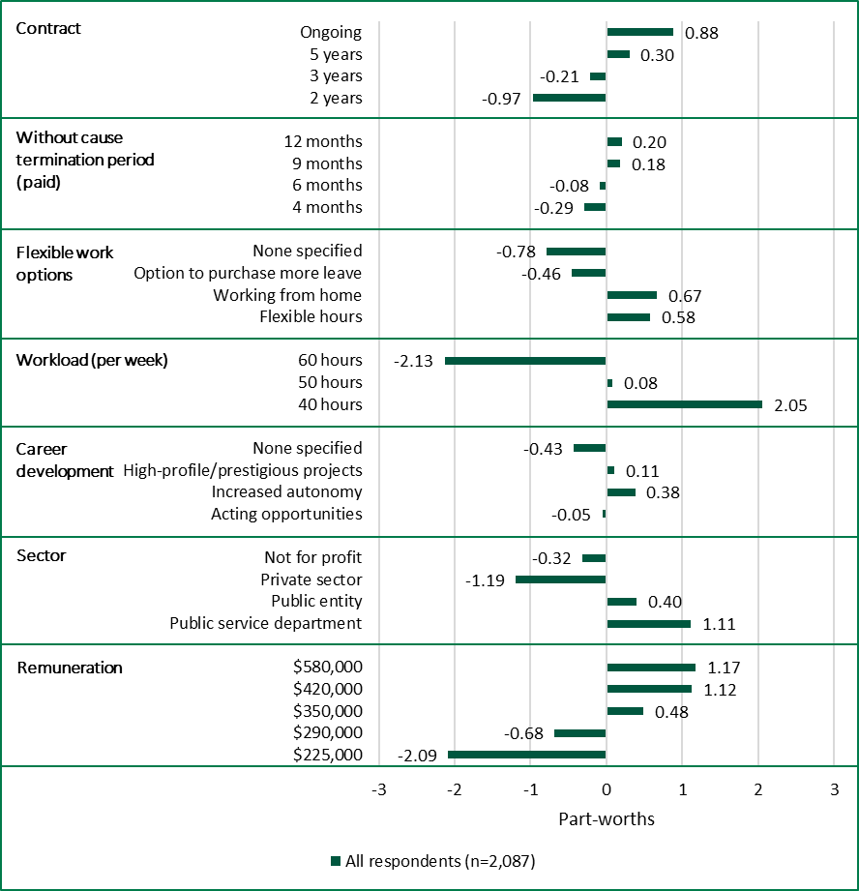

Source: Tribunal analysis of survey data.

Figure C.2: Average part-worths by current employment, public vs private

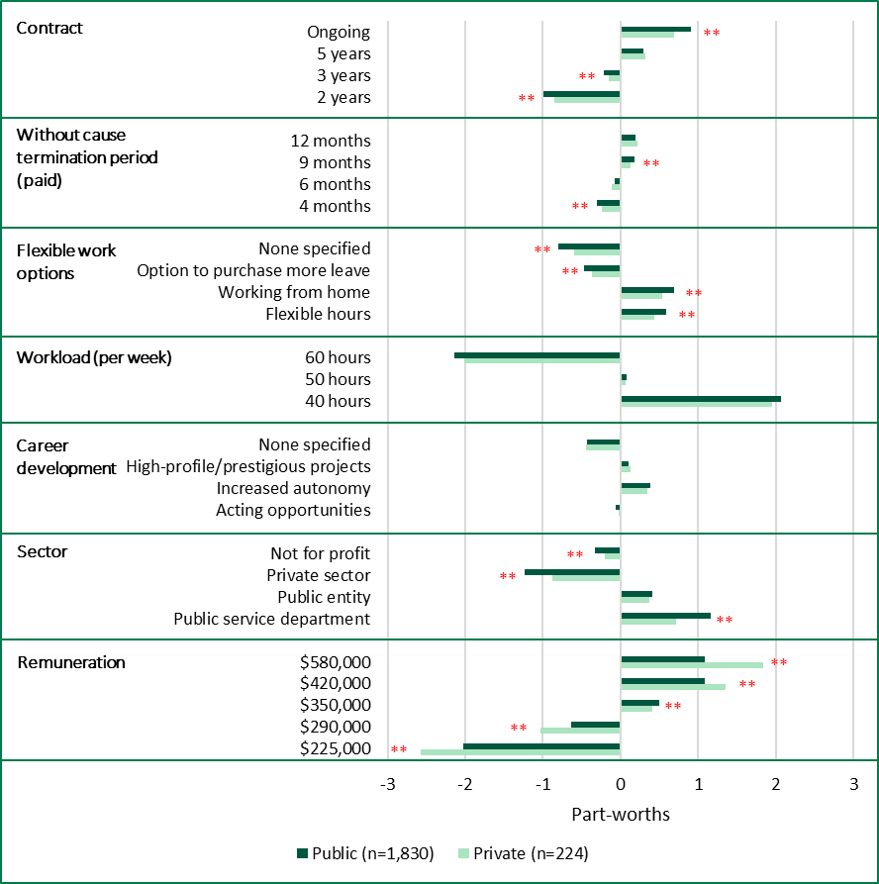

Note: The Tribunal conducted t-tests to determine whether part-worth values for particular levels differed significantly between respondents from the public and private sectors. ** means that the difference was significant at a level of 0.01.

Source: Tribunal analysis of survey data.

Figure C.3: Average part-worths by current employment, VPS vs PEs

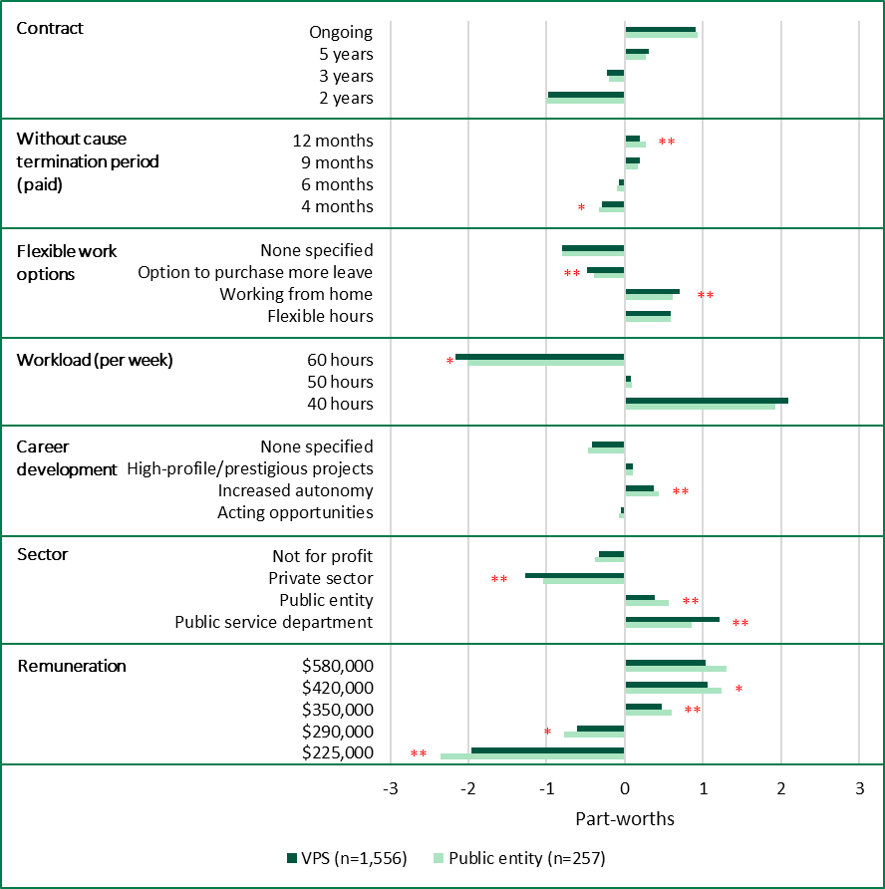

Note: The Tribunal conducted t-tests to determine whether part-worth values for particular levels differed significantly between respondents currently employed in VPS bodies and PEs. * means that the difference was significant at a level of 0.05, and ** means that the difference was significant at a level of 0.01.

Source: Tribunal analysis of survey data.

Figure C.4: Average part-worths by current role, engineering vs non-engineering

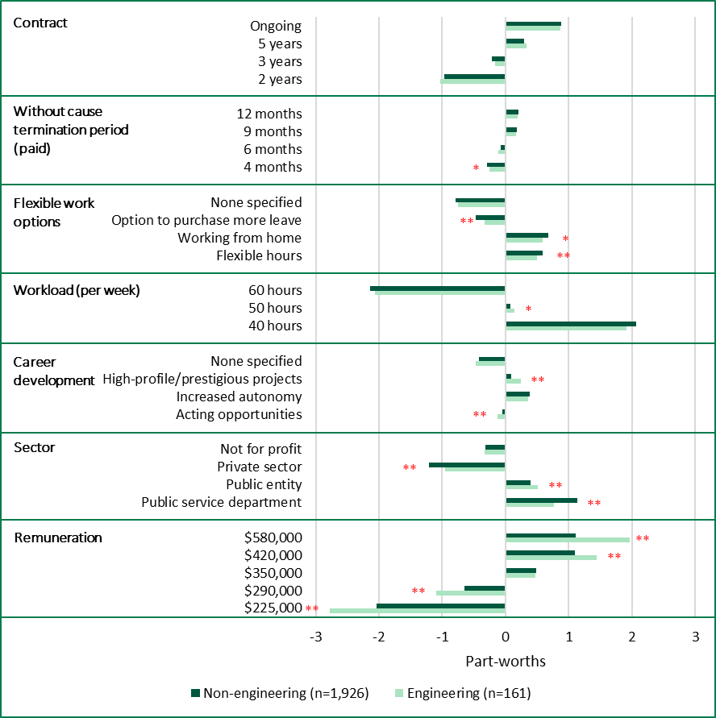

Note: The Tribunal conducted t-tests to determine whether part-worth values for particular levels differed significantly between respondents depending on whether their day-to-day work involves engineering. * means that the difference was significant at a level of 0.05, and ** means that the difference was significant at a level of 0.01.

Source: Tribunal analysis of survey data.

1. *Victorian Independent Remuneration Tribunal and Improving Parliamentary Standards Act 2019* (Vic) (VIRTIPS Act).
2. VIRTIPS Act, s. 36(6).
3. VIRTIPS Act, s. 38.
4. Victorian Independent Remuneration Tribunal (2024b), pp. 14, 17-18.
5. Victorian Auditor-General’s Office (2005), p. 45.
6. PwC (2021), p. 5.
7. Gartner (2018), p. 11.
8. Gartner (2019), pp. 1, 6.
9. Gitman L et al. (2018), pp. 340-341.
10. Acquah A et al. (2021), p. 26.
11. Kurt S (2023).
12. Alshmemri M et al. (2017), pp. 12-13.
13. Latham G and Pinder C (2005), pp. 488-491.
14. Hays (2025), p. 21.
15. Hays (2025), pp. 22, 37-38.
16. Milkovich G et al. (2014), pp. 12, 221.
17. Ronda L et al. (2020), pp. 1546-1561.
18. Ronda L et al. (2020), p. 1552.
19. Chapman D et al. (2005), p. 938.
20. Berkman E et al. (2016), p. 16.
21. Ward S (2024), p. 1129.
22. Chen Y et al. (2012), p. 1.
23. Ward S (2024), p. 1129.
24. Cohen D et al. (2019), p. 477; Ward S (2024), p. 1129.
25. Latham G and Pinder C (2005), pp. 504-505.
26. ABS (2024).
27. CEDA (2025), p. 2.
28. Vij A et al. (2023), p. 783.
29. Vij A et al. (2023), p. 784.
30. Bloom N et al. (2024), p. 920.
31. Hu J and Hirsh J (2017), pp. 1-2.
32. Ward S (2024), p. 1130.
33. Hu J and Hirsh J (2017), pp. 2-3.
34. Ward S (2024), pp. 1139-1140, 1144-1145.
35. Azgad-Tromer S (2017), pp. 342-343; Van Tuin L et al. (2020), p. 1.
36. BHP (2024).
37. Australian Human Rights Commission (2008).
38. Azgad-Tromer S (2017), pp. 356-357; Van Tuin L et al. (2020), pp. 7-9.
39. O’Reilly C and Chatman J (1996), p. 166. For an example of this definition being used in subsequent literature, see Sull D et al. (2019).
40. Panneerselvam S and Balaraman K (2022); Theys N and Barkhuizen E (2022), p. 4; Harvard Division of Continuing Education (2025).
41. Glassdoor (2019).
42. United Nations Development Programme Global Centre for Public Service Excellence (2015), p. 5.
43. Boruvka E and Perry J (2020), p. 569.
44. Boruvka E and Perry J (2020), p. 572.
45. Lapuente V and Van de Walle S (2020), p. 462.
46. Lapuente V and Van de Walle S (2020), p. 465.
47. Lapuente V and Van de Walle S (2020), p. 467.
48. Lapuente V and Van de Walle S (2020), p. 469.
49. Boruvka E and Perry J (2020), p. 572.
50. United Nations Development Programme Global Centre for Public Service Excellence (2015), p. 10.
51. Boruvka E and Perry J (2020), p. 573; United Nations Development Programme Global Centre for Public Service Excellence (2015), pp. 10-11.
52. Perry J and Wise L (1990)*.*
53. Anderfuhren-Biget S et al. (2010), p. 221.
54. Fennessy A (2022).
55. Buelens M and Van den Broeck H (2007), pp. 65-66.
56. Buelens M and Van den Broeck H (2007), p. 70.
57. Van Triest S (2024), p. 235; Meng F and Wu J (2017), pp. 1306-1307, 1315.
58. Anderfuhren-Biget S et al. (2010).
59. Van Triest S (2024), p. 244.
60. Vandenabeele W and Penning de Vries J (2016), p. 3*.*
61. Vandenabeele W and Penning de Vries J (2016), pp. 6-7.
62. Ripoll G et al. (2023), p. 194.
63. Ripoll G et al. (2023), pp. 193-197.
64. Bozeman B and Su X (2015), pp. 701-704.
65. Hinna A et al. (2021), p. 52.
66. Ripoll G et al. (2023), p. 6; Vogel R and Satzger M (2024), pp. 180-197.
67. Vogel R and Satzger M (2024), pp. 190.
68. Binu Raj A (2021), pp. 203-226; Clarke M and Scurry T (2017), pp. 966, 969-970, 980-986.
69. State Services Authority (2006), p. 26.
70. Hinna A et al. (2021), p. 52.
71. Johnston K (2025), pp. 167-168.
72. Victorian Independent Remuneration Tribunal (2024a)*;* Victorian Independent Remuneration Tribunal (2024b).
73. *Public Administration Act 2004* (Vic), s. 25.
74. Those regulations state all public entities are prescribed unless they are specifically excluded (reg. 5(1)). Entities that are not prescribed include public hospitals and public health services within the meaning of the *Health Services Act 1988* (Vic), Ambulance Victoria, the Victorian Institute for Forensic Mental Health, school councils, SEC Victoria and its subsidiaries, and certain committees of management.
75. While public hospitals and certain other Victorian public health sector organisations are not prescribed, a similar framework applies to them under the separate Health Executive Employment and Remuneration Policy managed by the Department of Health.
76. Hill J et al. (2011), p. 559.
77. ABS (2024).
78. Fair Work Ombudsman (n.d.).
79. Productivity Commission (2009), pp. 235-236.
80. Productivity Commission (2009), p. 234; Egan Associates (n.d.)*.*
81. Australian Council of Superannuation Investors (2023), p. 23.
82. VPSC (2021).
83. WGEA (2024), p. 11.
84. WGEA (2024), pp. 11, 41-45.
85. Victorian Independent Remuneration Tribunal (2024a), pp. 130-133; Victorian Independent Remuneration Tribunal (2024b), pp. 142-146.
86. Victorian Independent Remuneration Tribunal (2024b), p. 141, Victorian Independent Remuneration Tribunal (2024a), p. 128.
87. Victorian Independent Remuneration Tribunal (2024b), p. 142, Victorian Independent Remuneration Tribunal (2024a), p. 129.
88. Mercer (2024), p. 26.
89. Mercer (2024), p. 26.
90. Victorian Independent Remuneration Tribunal (2024b), pp. 72-73.
91. Victorian Independent Remuneration Tribunal (2024a), pp. 83-84.
92. Victorian Independent Remuneration Tribunal (2024a), pp. 84-85.
93. Bardoel A et al. (2003).
94. Bardoel A et al. (2003), p. 50.
95. Bardoel A et al. (2003), p. 38.
96. Orme B (2010), pp. 78, 186.
97. For further information about Hierarchical Bayes estimation, see Orme B (2010), pp. 167-168.
98. Walasek et al. (2024), pp. 1-2.
99. The lower bound of the estimate is based on data for respondents currently working in the private sector and the upper bound is based on data for respondents currently working in the VPS.
100. The lower bound of the estimate is based on data for respondents currently working in the private sector and the upper bound is based on data for respondents currently working in the VPS.
101. Miller S (2015).
102. Chassamboulli A and Gomes P (2019), p. 9.
103. Cavalcanti T and Santos M (2021), p. 955; World Bank (2021), p. 26.
104. Victorian Independent Remuneration Tribunal (2024b), p. 43.
105. Victorian Independent Remuneration Tribunal (2024b), pp. 43, 48.
106. VPSC (2022).
107. Victorian Independent Remuneration Tribunal (2024b), pp. 131-132.